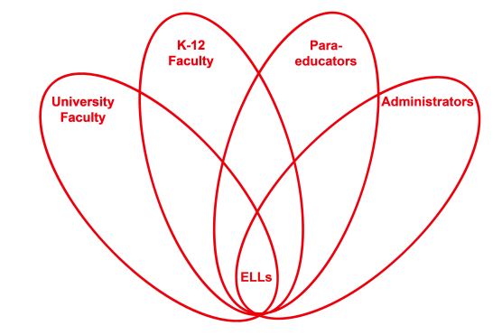

RETELL Strategy Implementation in the Classroom

Teacher | Stacy Sirmaian
Content Area /  Grade Level | Science/Kindergarten
Unit  (Topic or Skill) | Science/ Wood Unit
Content Objectives | RI.K.2 SWBAT demonstrate an understanding of the process of how a chair is made through the sequence of pictures.
Language Objectives | SWBAT orally retell and sequence the process of how a chair is made, using pictures to support their thinking.
Strategy | Double Entry Journal Strategy
Brief explanation of how the strategy was used | I began the strategy lesson with an introduction of the text features (the content was about wood and the purpose was how the tree becomes a chair). After explicitly going over the text features we noticed a phrase on the back of the book, which said “Here is chair you might sit on in a park. Do you know how it’s made?” I then model a think aloud: “Where does a chair come from?” This lead to us creating a double entry journal strategy to find out what the students knew about how a chair came to be with interactive writing. Then I read the story, “The Story of A Chair.” Then as a group we retold the steps it took for the tree to become a chair using pictures from the story and connecting words. I discussed with the children the connecting words to help guide them in their discussion. The students then turned to their partners and explained the steps in their own words at their own level. I then called a few students up to share their events using the connecting words and pictures.
Reflection: How and why was the strategy effective? What might you change for next time? | This strategy enabled the students to respond in speaking, listening and interactive writing. When the students were retelling the sequence of events with their partner and in front of their peers, they were speaking, listening and actively engaged.  The next time I try this strategy, I would start with minimizing the number of events in the sequencing. I realize after the lesson that the sequence of events for the L1 and L2 had too many steps. Between the connecting words and the new vocabulary presented in the text , it was a lot for them to process. The L1 and L2 students needed a lot of assistance filling in the vocabulary and connecting words to support the retell. In comparison, the L3 and L4 students had less difficulty and needed very little support with the vocabulary.  Now that the students have had exposure to the vocabulary and connecting words at the right level and pace, I feel that the next day’s lesson will enable my ELLs to successfully retell the events.

