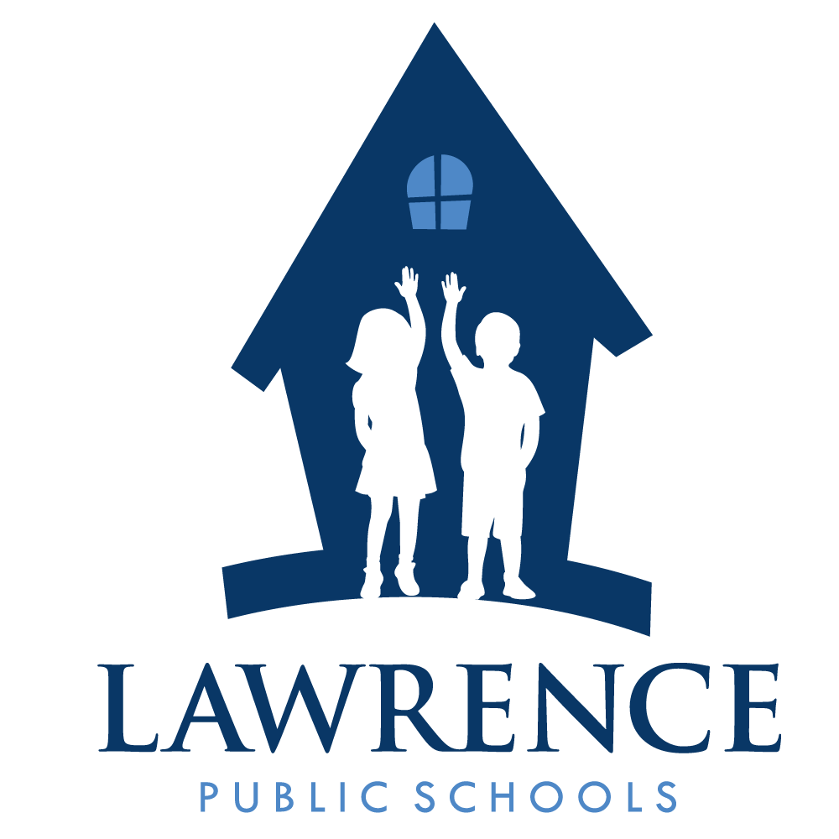
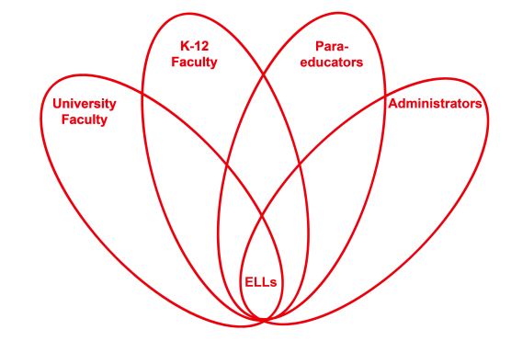

RETELL Strategy Implementation in the Classroom

Teacher | Joshua Segaloff
Content Area /  Grade Level | Science Middle School Grade 7
Unit | Columbus misconceptions – round earth vs. flat earth
Content Objectives | I will examine the problems Columbus faced on his journey to America.
Language Objectives | I will read a nonfiction text and write about the problems Columbus faced.  Language Objective Differentiation for Proficiency Levels:  - Students will demonstrate their knowledge of tiered vocabulary by participating in pair and small group discussion.  - Students will write short notes and then respond to notes in own words.  - Students will orally express cause/effect relationships between historical events with peer and teacher support.  - Students will write answers to text dependent questions with support from another student.
Strategy | Double Entry Journal
Brief explanation of how the strategy was used | Lesson Sequence: Introduce the lesson by asking the students who is Christopher Columbus? I build some background about Columbus and front load vocabulary that will be important for understanding the nonfiction text. We discuss who the audience is when reading this text. I introduce the double entry journal by showing a template on the Mimio. I use a think aloud for the first paragraph and take notes on the left side and then react to the notes on the right side. Students work in pairs to read and complete the double entry journal for pages 2 and 3, then attempt to complete the last page independently. I walk around the room and help my ELL and SPED students as needed.
Reflection: How and why was the strategy effective? What might you change for next time? | Since the text was nonfiction, the double entry journal made it easier for my students to chunk information and make sections more comprehensible. By writing notes on one side and then responding to those notes students are forced to spend time trying to understand the material. The pace is slowed down and time and effort is evident as my students respond to their reading.  This strategy helps improve my students’ academic language because they are paired with a proficient English student. They discuss the notes that are most important to add to the journal. They need to express their thoughts and opinions before they respond to the other side of the journal entry. The academic language is built through students using quotes from the text or using my teacher-directed prompts.  The next time I use this strategy to engage my level 1 and 2 students I will have them use the diagrams or pictures on the left side of the journal and then have them respond to those images on the right side. I could have them describe what they think they see or reflect on the image.

