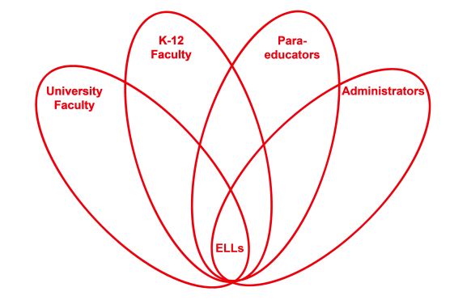

RETELL Strategy Implementation in the Classroom

Teacher | Paul Flanigan
Content Area /  Grade Level | Language Arts Grade 5
Unit  (Topic or Skill) | Wringer by Jerry Spinelli  Finding information in a text
Content Objectives | Students will identify the emotions the main character goes through on a particular day each year.
Language Objectives | Students will write about the thoughts/emotions the main character is having on specific days in the story.
Strategy | Double Entry Journal
Brief explanation of how the strategy was used | In the Left column, students were asked to write sentences, phrases or words from the book of the character’s description of three Pigeon Days he had attended (Age 4, 5, and 6). In the right side column, students were asked to describe the main character’s thoughts and emotions on these days. The thoughts and emotions could be written in their own words.  (See image below)  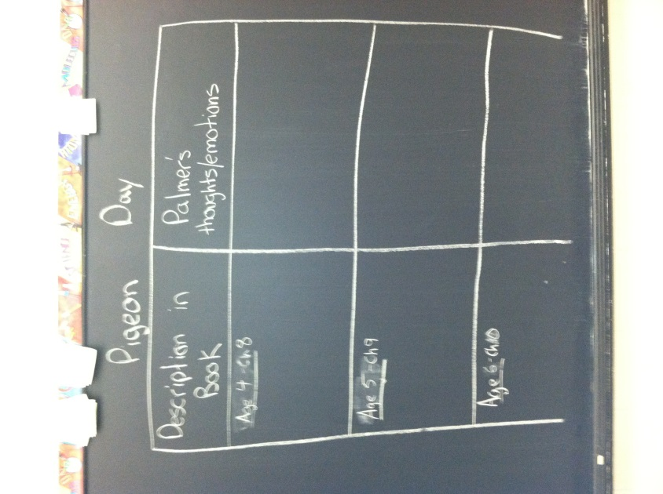
Reflection: How and why was the strategy effective? What might you change for next time? | The strategy was effective because it asked the students to look for specific information in the text. Looking for broad topics often causes confusion.  The next time I try this strategy, I would build upon this chart which they have already started because the climax of the story happens on a Pigeon Day that we have not yet read about. Additionally, I would model this activity for them using a different day (special day) from the story and another character’s thoughts/emotions. I would model the main character’s mother’s description and thoughts/emotions of his birthday parties. I have discussed these in earlier think alouds but this written version will provide the students with an example using similar days which they have read about. This modeling will allow them to see how far these thoughts can go.  Finally, during the sharing of this information, I will allow the students to expand verbally on what they have written. Though they were able to write about the emotions and thoughts in their own words, I feel that they will be able to share more and get more in depth by allowing them expand on what they have already written.

