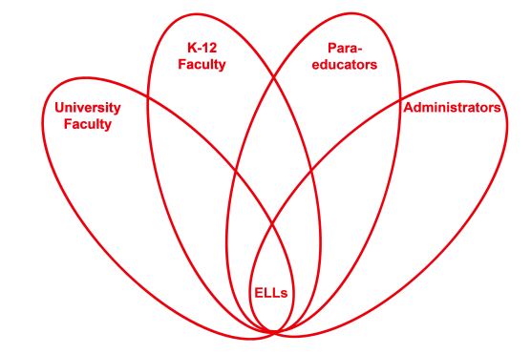

RETELL Strategy Implementation in the Classroom

Teacher | Diane Fortier
Content Area /  Grade Level | Kindergarten
Unit  (Topic or Skill) | Writing
Content Objectives | Students will participate in revising a previously written paper.
Language Objectives | Students will read and listen to a piece of writing being read and verbally give comments as to what words need to be added, deleted or changed in order to make the writing piece more cohesive.  W1 will vote with thumbs up or thumbs down if they like the sentence the way it was written, if they feel the words need to be changed, or if they like the suggestions made by peers.  W2 will give one word or short phrase answers or suggestions for revisions  W3/4 will speak in sentences to offer suggestions to revise each sentence
Strategy  (Name or Type) | ‘Cut and Grow’ strategy was used to revise a piece of writing previously written by the students.
Brief explanation of how the strategy was used | Teacher took the written student work and separated the sentences, placing each sentence underneath the other on the board. Spaces were left in between the sentences for revisions.  Each sentence was read and discussed with the group. Teacher made adjustments to the sentences as the students suggested.  Sentences were moved around, words were changed and a final sentence was added to the end.  Entire story was reread.  Students then were asked to illustrate the story we wrote.
Reflection: How and why was the strategy effective? What might you change for next time? | This piece of writing had 4 phrases and one sentence. Combined, it was supposed to tell a story about a dog. The students needed only one initial reading of the piece to make comments that the phrases did not make sense. As we worked through each phrase, I led the group to discuss what each phrase meant and whether or not all the words were there for us to understand it. We slowly built the phrases into complete sentences. Although I have not taught the words noun or verb, these students were able to say which words were missing from the sentence and give suggestions. We reread the entire piece a few times as we were working on the process and students were able to say that one sentence should be moved as the two things the dog played with should be together. There were a few times that incorrect verb tenses were offered and students corrected each other.  The students stayed invested in this process. At the end, one ELL said he thought we needed one more sentence to tell that the dog went home. After the new piece was read the students voted that they liked the story better now than when we started. They said they could understand it better.  Students were invested in this activity. The topic was familiar enough that everyone had some comment to make, even as little as that ‘dogs are not that color’. A great deal of conversation bubbled around each sentence as the students gave their own comments and backed up their suggestions. Students agreed and disagreed with each other. The conversation was lively. We did not move on until everyone agreed. I remained neutral just repeating the sentences and asking if the sentence made sense and did they like the way it sounded.  I liked the way the writing was familiar to them and that they were already familiar with the topic. The fact that they were revising work that they had done was important to them. Revising is familiar to them as we revise during writers’ workshop but it is a lot of work for kindergarten students. It usually is not a process they enjoy. This time they did not have to do the writing. They just talked and I wrote. This technique did not slow down their thinking process. When they revise their own work it is really hard for them to think about the change they are going to make, to form the new letters and record them without losing their train of thought.  I liked doing first the ‘write around’ story strategy as everyone was part of the story and then following it up with this ‘cut and grow’ strategy. Everyone saw the revising process to completion. I think it will help the students as they go back and revise more of their own writing pieces. I will try this series again in the next unit and see if I get the same or better results.

