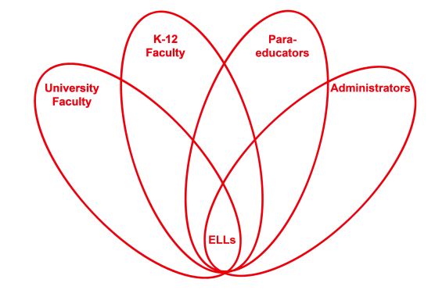

RETELL Strategy Implementation in the Classroom

Teacher | Stacy Sirmaian
Content Area /  Grade Level | Kindergarten
Unit  (Topic or Skill) | Gingerbread Unit
Content Objectives | ELA-Literacy RFK.1 Demonstrates understanding of organization and basic features of print.  ELA-Literacy RFK.1a Follows words from left to right, top to bottom and page to page  ELA-Literacy RFK.2d Isolate and pronounce initial, medial vowel and final sound.  ELA-Literacy RFK.2 with prompting and support, retell familiar stories including key details.  SWBAT use their knowledge of print , early literacy strategies and recall, to assemble a text (phrase) in the  correct order. They will use 1 to 1 word match when orally  stating the phrase using the complete text.
Language Objectives | SWBAT construct a text phrase and state / repeat the text orally to a friend.  Language Objective Differentiation for Proficiency Levels:  L1 I can find and match word or phrase.  L1 I can repeat simple word or phrase.  L2 I can distinguish between same /different form of print  L2 I can connect oral language to print
Strategy | Cut and Grow
Brief explanation of how the strategy was used | I began the lesson by having the students remember the famous phrase that was in the “Gingerbread Man and  Boy” stories. The students turned and talked with their partners to discuss their thoughts. I then called on a student to share her response. As the student said, “Run, run”, I placed a pre-written strip that says “Run, run” up on to the board. I continued this process till the phrases were completed. As a whole group we recited the phrases. I then had the group close their eyes and scrambled up the sentences. I then called a few more students up to reconstruct the order of the phrases. The students would read the previous phrase to help them construct the new phrase. By reading the previous phrase it enabled them to hear the rhythm, and the rhyme and if needed some students were using beginning letters to figure out which phrase went next. The students were then sent to their tables to work collaboratively in a group to assemble their phrases in order.
Reflection: How and why was the strategy effective? What might you change for next time? | The students were using recall and were actively engaged in turn and talk with their partners. The ELLs were actively engaged in chiming in with the rhyme which was producing the language. The rhythm and the rhyme of the phrase made the flow easy for the students to say and remember. The students used oral language while reciting the model phrases back. They matched 1 to 1 word as they read the phrases. They also worked cooperatively at tables reading phrases and putting them in order which helps to teach them about grammatically correct sentences. To increase my ELLs engagement and interaction, the next time I try this strategy, I would have the students use more poems and songs in other content areas. The students were very excited and enjoyed participating in the cut and copy strategy. My ELLs felt successful even though they could not read every word in the phrase. Just knowing even the rhythm and the rhyme was very helpful to them. Some of my students used the beginning sound to help figure out which phrase would go next. Even though only a few children used it, leaving the model up was also a great idea because it gave  them a crutch to turn to.

