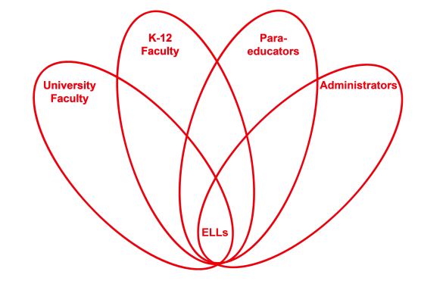

RETELL Strategy Implementation in the Classroom

Teacher | Carlene Hackett
Content Area /  Grade Level | Reading/Social Studies  Grade 4
Unit  (Topic or Skill) | Reading/Writing
Content Objectives | Students will refer to details and examples in a text when explaining what the text says.
Language Objectives | Students will use text to describe the events during the Westward Expansion.
Strategy  (Name or Type) | Cut and Grow
Brief explanation of how the strategy was used | After using the strategy “Write Around” students now have a paper to use for this strategy “Cut and Grow”. On the next day students will read their paper and figure out where they can improve their paragraphs by adding more details. The students will cut out the sentences and glue them on construction paper, leaving space for where they want to add more to their paragraphs. Students will be able to use details from several stories that we have been reading about the pioneers and Westward Expansion. Students can share their new paragraphs on their construction paper by using the mimio for the class to see or can be viewed by a gallery walk.
Reflection: How and why was the strategy effective? What might you change for next time? | This strategy was effective due to the limited amount of work an ELL student has to complete to have a detailed paragraph. ELL students have exemplar sentences that they can use in their own writing, which is great for students.  When placing students in a group, be careful to place ELL students in groups with high achieving students so they have great role models.

