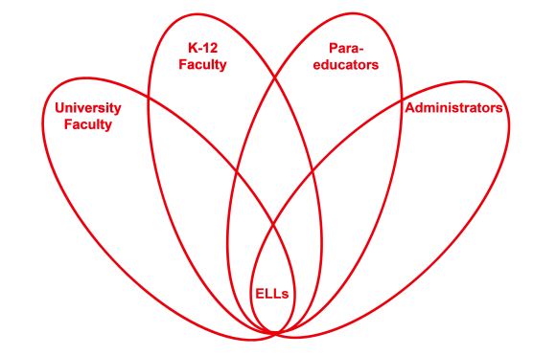

RETELL Strategy Implementation in the Classroom

Teacher | Sonya Dugan
Content Area /  Grade Level | 2nd Grade ELA
Unit  (Topic or Skill) | Writing
Content Objectives | Students will be able to recognize Martin Luther King, Jr. and understand the reason we celebrate him.
Language Objectives | Students will be able to identify and share 3 facts or events about Martin Luther King, Jr.  Language Objective Differentiation for Proficiency Levels:  Students at WIDA level 2:  - students will be able to orally state events from Martin Luther King, Jr's life.  - students will be able to have conversation using details from stories read to them about Martin Luther King, Jr.  - students will be able to provide information using a graphic organizer (adding to chart paper)  Students at WIDA level 3:  - students will be able to orally state and/or write at least 3 events about Martin Luther King Jr's life.  - students will form simple sentences using events in context (who he was, what he did, why?...)  - students will be able to provide information using an individual graphic organizer
Strategy | Cut & Grow
Brief explanation of how the strategy was used | Prior to this writing lesson, the class was read Martin's Big Words by Doreen Rappaport. In this lesson, they are writing about why we celebrate Martin Luther King, Jr. Day  After the story, the students shared some of their ideas of why Martin Luther King Jr. was such an important person, what he did to help others, and/or why the book was called, Martin's Big Words. These answers were recorded on chart paper.  Cut-n-Grow Writing:  The students choose a sentence from the recorded responses on the chart paper and write it on their own response paper.  Then, they cut each word out of the sentence and create a "bigger" sentence by gluing the words on a piece of construction paper and adding additional words to it. Prompt for specific language related to story.  Ex.  Martin Luther King, Jr. was an important man. (cut each word out and place on paper. Words can be rearranged to suit student's response - then additional words are added and/or deleted in sentence)  New Sentence Example: Martin Luther King, Jr. was an important man because he helped people peacefully.
Reflection: How and why was the strategy effective? What might you change for next time? | This strategy allowed my ELL students to feel successful because they were able to share the events of the day without having to come up with all of the details individually. They were able to converse about the events of Martin Luther King Jr's. life and experiences. Although they were not able (in some instances) to read what was written on the chart, they were able to fully participate as it was read to them and they were able to revisit the chart in order to form their own sentences.  This strategy allowed my students to start with the basic sentence that they came up with, then listen to all of the other responses - which triggered additional thinking and brought up some additional thoughts that they decided to add to their sentences. They attempted (in some cases) to use language from the story ("whites only") in their writing. It generated conversation about the events of that time and allowed the students time to discuss it and share their thoughts.  The next time I try this strategy, I would:  - Pick a sentence or two for them (which would still allow them to pick one of their own) to work with. It was a little overwhelming (for a few) to pick the sentences they wanted to use. Although they were engaged (and fascinated) with the story/lesson, it was a bit daunting to keep going back to the sentences on the chart paper.  - OR, depending on their level, have 5 sentences pre-written and allow them to pick from those.  - My thought was to let them choose from the list we made as a whole group to allow them the flexibility to write about what they wanted, but it was too much to have the whole class' responses to pick from.

