Collaborative Analysis of Mentor Text
Description of Practice: Teacher-facilitated analysis of a class text can help students make sense of the often confusing “fire hose” of information these texts contain. Yet it is essential that all students, including ELLs, learn to dissect a text to obtain critical information. Thus it is important that the teacher practice this gradually, beginning with highly guided readings and progressing to more and more challenging and dense examples. In each case, collaborative discussion that involves the students as much as (or more than) the teacher will ensure that students acquire this capability for their own use.

Intended Audience and Outcomes: Teachers can use this strategy to encourage their students (including ELLs) to develop familiarity, confidence and skill at deciphering a rather dense text that contains new academic language. In addition to read-aloud practice, this makes for terrific classroom discussion (see the example below).

Evidence that it works: Many math teachers (including me, for years) have used facilitated student reading aloud and class discussion to help students make sense of new concepts. Students gain practice in “cracking” the information in the text, and it generates rigorous classroom discussion that can, in turn, lead to problem solving or writing in which students can further articulate their thinking.

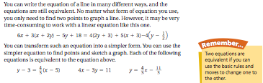

Example: Some important language here to practice (equation, equivalent, transform, simpler) but also a key concept to discuss: the first, long equation is difficult while the shorter, transformed equations are simpler and easier!

