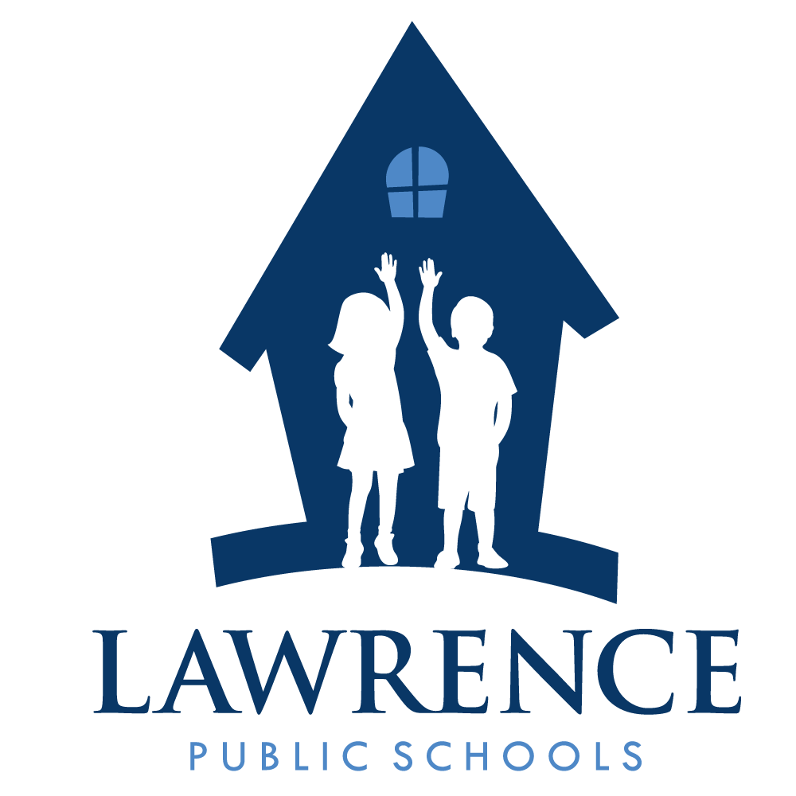
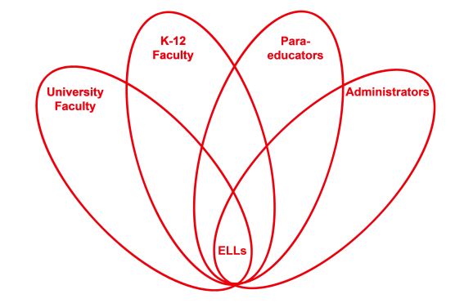

RETELL Strategy Implementation in the Classroom

Teacher | Heidi DeLucia
Content Area /  Grade Level | Kindergarten
Unit  (Topic or Skill) | Harvesting/Farming Unit
Content Objectives | SL.K.1 SWBAT: participate in collaborative conversations with diverse partners about kindergarten topics and texts with peers and adults in small or larger groups.  L.K.1f SWBAT: produce and expand complete sentences in shared language activities.
Language Objectives | SWBAT: discuss with a partner what harvesting mean to them. They will be able to draw, write and share this information with the class.  Level 1: Students can draw pictures and trace/write letters of dictated words which describe their illustrations.  Level 2: Students can illustrate a picture and restate some facts about it. They can write letter sounds heard within words to describe their illustration.
Strategy  (Name or Type) | Artistic representation Sentence Starter Share
Brief explanation of how the strategy was used | To begin the lesson, I reviewed the word wheel created the prior day and we recited the poem “Harvest Time” again. In turn and talk fashion, the students discussed what harvesting meant. They were given a sentence starter Harvesting is… and were sent off to draw a picture to match their writing. Students were allowed to share their artwork and read their sentence(s) in whole group.
Reflection: How and why was the strategy effective? What might you change for next time? | This was enjoyed by all of my students. Giving them the chance to draw their thoughts made all of them feel successful. Many used inventive spelling and wrote just the beginning sounds to words, but felt pride in their accomplishment.

