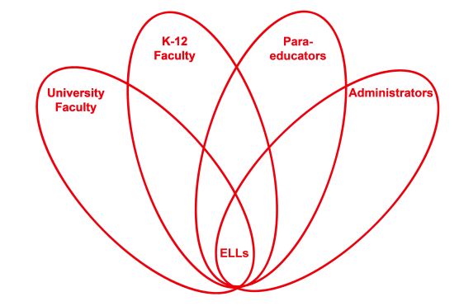

RETELL Strategy Implementation in the Classroom

Teacher | Kate Vachon
Content Area /  Grade Level | Kindergarten
Unit  (Topic or Skill) | Analyzing Text Features
Content Objectives | Students will know that labels help the reader to understand what is happening in the photos/illustrations and how that helps to understand the information in the text.  RI.MA.5 Kindergarten Identify the front cover, back cover, and title page of a book  RI.MA.6 Kindergarten Name the author and illustrator of a text and define the role of each in presenting the ideas or information in a text  RI. MA.7 Kindergarten With prompting a support, describe the relationship between illustrations and the story in which they appear.
Language Objectives | When given a non-fiction text to read, students will be able to identify where the labels are when asked.  Level 4: The student will be able to locate by pointing to the labels in the presented text when asked, “Where are the labels for these photos?”
Strategy  (Name or Type) | Analyzing Text Features  Have the text features enlarged model book cover up on the easel  Have the labels from the photos (apple, bread, marshmallows, popcorn, turkey, and watermelon) written on cardstock large enough for everyone to see  Have an enlarged model text page that has labels on it
Brief explanation of how the strategy was used | 1. Point to the enlarged model book cover and review learned text features (Title and Author), asking students what they are called  2. Show students the new book  3. Point to the photo on the cover; ask students what is happening in the photo  4. Point to the title of the book and read it out loud; ask students if the title matches the photo  5. Point to and read the author’s name  6. Ask students if the book is fiction or non-fiction  7. Point to the enlarged model text page with labels; explain that a label helps us to know what the photo is showing us and helps us connect the photo to the written words; discuss the sample  8. Do a picture walk with the students pointing out the caption and labels (use the terms caption and label); Ask students if the photos match the title and cover photo  9. Go back to the beginning of the book to the Picture Dictionary; explain what it is and how that helps us understand the book  10. Go through the book and point out the labels; explain that they tell us specifically what the words are telling us  11. Read the book out loud to the students pointing to the words as I read, including the labels  12. Ask students what they learned from the book and if the Picture Dictionary and labels helped them understand the book
Reflection: How and why was the strategy effective? What might you change for next time? | By using enlarged visual samples/models that are clear and specific, paired with verbal language, my student was able to understand that the labels in a text help him to know what the photos in a non-fiction book tell him. The practice with an individual text reinforced this learning and understanding.

