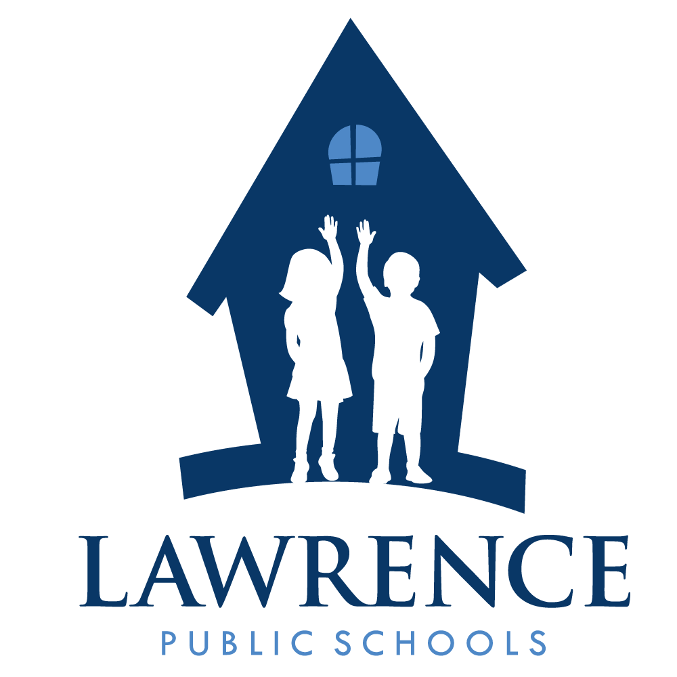
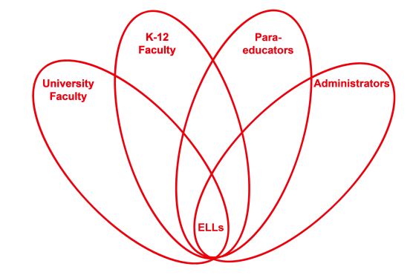

RETELL Strategy Implementation in the Classroom

Teacher | Linda Fiorillo
Content Area /  Grade Level | Kindergarten
Unit  (Topic or Skill) | What is Veteran’s Day?
Content Objectives | Students will be able to identify Veteran’s Day as a United States patriotic holiday and describe reasons the day is celebrated.
Language Objectives | Students will verbally discuss Veteran’s Day and tell why it is  celebrated.  Language Objective Differentiation for Proficiency Levels:  L1 Students will be able to verbally repeat vocabulary words  L2 Students will describe Veteran’s Day using pictures with  words.  L3 Students will be able to explain Veteran’s Day with  details.
Strategy | 7-step Vocabulary Process
Brief explanation of how the strategy was used | - I chose words that I thought were most important (tier 2 and tier 3) to describe the Veteran’s Day holiday such as Military, Army, Navy, Coast Guard, Air force, Marines, serve, brave, Veteran, protect, America, and freedom and wrote them on index cards with pictures. I explained each word with pictures.  - I defined each department of the military with definitions and provided large pictures and examples for each such as, Army, Navy etc. I also defined the other words with picture cards as well.  - The students verbally repeated each word followed by snapping and clapping each word as I presented them one by one.  - Next, I instructed the students to listen to a short story followed by a video, and to listen and look for the words that I explained. While reading the book and showing the video, I paused to highlight words, show real- life pictures and asked students to repeat words.  - After the video, I asked children to get into partners. I paired the ELL readers with lower level ELL readers. The readers could read the word, while the ELL non- readers could match the word to the resource pictures on the wall and then they discussed the words.  - Next, I gave the definitions. The children needed to listen and look at their word. If their word matched my definition, they were to say and show their word/picture to the class and go up to the front of the class and place their word around the Veteran on the poster.  - After all words were discussed, the students wrote their words in books and drew pictures. They were encouraged to discuss the pages as they worked with friends at their table.  - The books were to go home as added reinforcement of vocabulary and content so that the students could practice their words as they read the book to family members.  - I wrapped up by asking what Veteran’s Day was and waited for verbal responses from the children.
Reflection: How and why was the strategy effective? What might you change for next time? | This was very interesting. I pre-loaded the vocabulary with pictures and words. I explained the words and provided pictures as additional resources. The pictures act as a reference and help to trigger responses when children are unsure or are forgetful of a word. I asked the children to repeat each word three times as I introduced the words. This strategy allows them to practice hearing and speaking the word. They become more comfortable and will remember more through repetition.  After, we read a book, which provided the words to be used in context and modeled in fluent ways. This helped them see the words in action and became more meaningful to them then just repeating words. After, we saw a video that showed real-life photographs of Veterans. This enhanced their understanding further and provided a better picture of what a Veteran was. It was interesting to note that we watched the video with another Kindergarten class. They did not have an introduction or pre-loaded vocabulary. The teacher of that class noticed and said out loud that my class seemed to answer all the questions and could respond positively to the questions that were asked. We both discussed how important it is to preload vocabulary before we do lessons for this was a clear example of how beneficial it seems to be.  I modeled the language and vocabulary. Students repeated words verbally and physically to practice saying the words. Students were paired to practice the language in comfortable ways with a friend. Students reported back as they responded to given definitions and placed words on the poster. Discussions were encouraged at the labs.  After the lesson, I reflected about what could have made the lesson even more effective. I thought that maybe next time when teaching, “Veteran’s Day”, I will have the children act out Army –marching soldiers, navy-waving arms to make waves of the ocean, air force-acting out flying a plane. This would be a fun and engaging way to learn the words.

