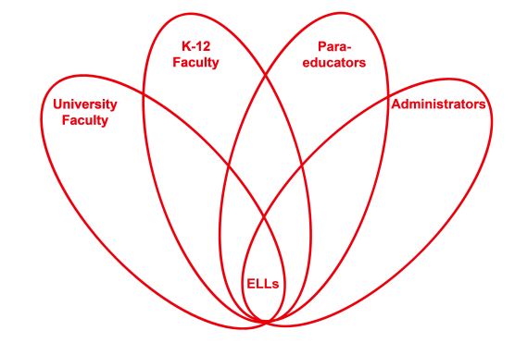

RETELL Strategy Implementation in the Classroom

Teacher | Heidi DeLucia
Content Area /  Grade Level | Kindergarten
Unit  (Topic or Skill) | Harvesting Theme  (Vocabulary)
Content Objectives | MA10. SWBAT: Actively engage in group reading activities with purpose and understanding.
Language Objectives | SWBAT: Orally discuss various habitats found on a farm, using the new vocabulary word(s) taught.
Strategy  (Name or Type) | 7 Step Strategy
Brief explanation of how the strategy was used | This was a whole group lesson prior to reading Barnyard Banter to frontload vocabulary within the text.
Reflection: How and why was the strategy effective? What might you change for next time? | This strategy worked well but the more I use it the easier it becomes. Providing the definitions in kid friendly language, helps my students understand the content better. I would have practiced the process a few more times, prior to my lesson introduction just to be more comfortable with the steps.

