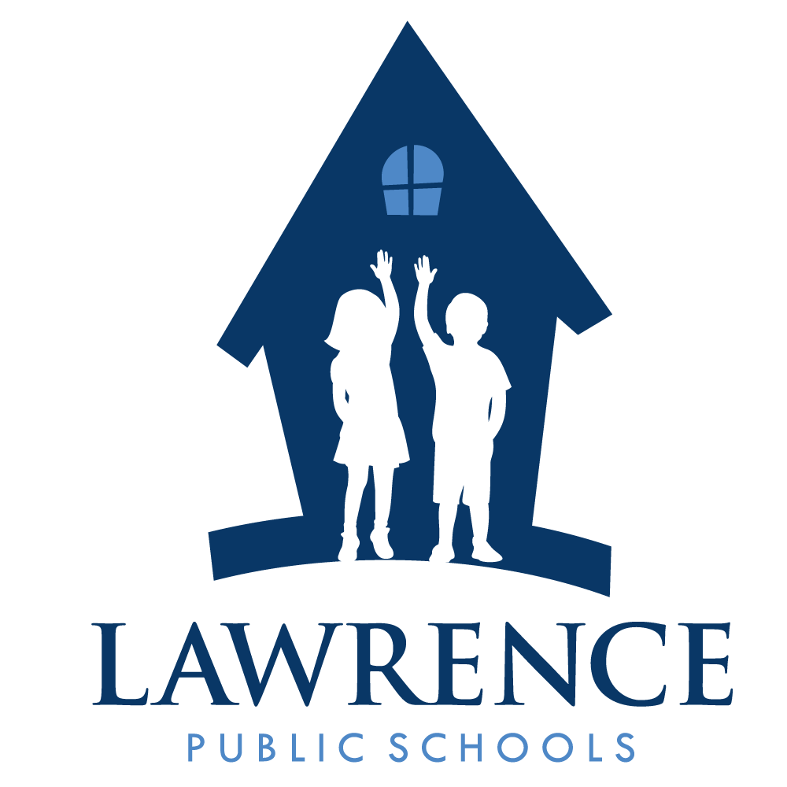
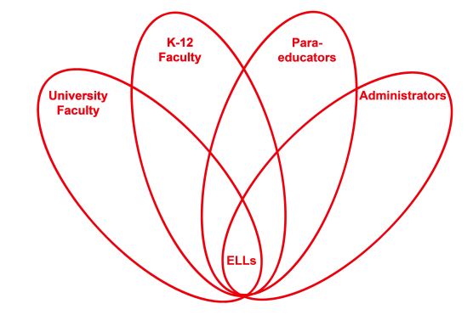

RETELL Strategy Implementation in the Classroom

Teacher | Diane Fortier
Content Area /  Grade Level | Kindergarten
Unit | Family
Content Objectives | Recognize and describe that families have similar and different characteristics.
Language Objectives | When given a group of people the student will be able to tell when the group is a family and name the members.  Language Objective Differentiation for Proficiency Levels:  Level 1 students can point to family member when asked ‘where is_____?’ as shown a picture of a family.  Student will draw picture of his/her family members.  Level 2 students can answer question ‘Where is ____?’ When shown a picture of a family.  Students draw picture of his/her family and label family members.  Level 3 students can answer question ‘What is the name of the family member that does ____ in the story?’  Student will draw picture of his/her family, label each member and discuss.  Level 4 students can find picture of family member that matches oral description.  Student will draw picture of family and use words and inventive spelling to tell story.  Level 5 students can describe their family using family names.  Student will draw picture of family and string words together to make short sentences to describe his/her family.
Strategy | 7 Step Vocabulary
Brief explanation of how the strategy was used | Initial vocabulary was taught during focus reading lesson and activities were done during lab/center time.  The 7 step vocabulary strategy was used to pre-teach family member target names : Mother, father, sister, brother, grandmother, grandfather, aunt, uncle, cousin.  1. Students look at pictures of family members: teacher says name, students repeat word. Sequence is repeated three times.  2. Student listens to sentence from book where the word is used.  3. Student listens to dictionary definition.  4. Teacher describes family member in student friendly language.  5. Discuss cognates and other names of each family member.  6. Using family vocabulary, students turn and talk to each other and define that family member.  7. Literacy Lab Activities:  Writing: students use sentence frame to answer “My _______ hugs me.” Picture/label cards are at table.  Art: draw a picture of your family and label.  Math: Choose outline shapes of family members for each member of your family. Compare your family with other members’ families at the table.  Library: read family books to a partner. Lower level Ell paired with English speaker.  ABC: students ‘write around room’ as they find family members and record name.  Literacy: level 3/ 4 students read poem, level 2 students match words to the poem and/ or level 1 students match sentences with picture to family poem.  Dramatic play: students dress and act out family situation using props to indicate which family member they are. Level 1 /2 students pair with English speakers.  Activity table: Students play ‘go fish’ using family member game cards. Teacher monitors ELLs to ensure language usage.  Pocket chart: Students will post their family pictures and discuss with other students.
Reflection: How and why was the strategy effective? What might you change for next time? | Using the 7 step vocabulary strategy clearly gave the students practice saying the family member names in English. It also gave a common understanding between all the students as to what family members are. It helped students transfer knowledge as the cognates were discussed. This book was an introductory book for the students to jump start the Family unit. By focusing on the basic words describing family members, the students were able to move forward into the more involved books and lessons with understanding and confidence.  Visuals assisted comprehension throughout lesson and labs. Some visuals were picture/word cards; others were the family pictures students brought from home as part of a homework assignment. While some students had brought pictures the first day, many more students brought in pictures after this first vocabulary lesson. This really sparked language from the level 1 and 2s in the following days.  Having the picture/word cards at each lab center made it easier for the students to use the vocabulary. I listened to the English speaking students offering the target language to the ELL level 1 and level 2 students as those students pointed to the pictures. Through the pictures and stories the students drew and wrote about, I was able to ask questions and expand what the students were describing and talking about.  During step 5 of the vocabulary lesson the higher ELL students jumped in and offered the cognates. This in turn naturally led into other names students call a parent or grandparent. The newcomer in my class got involved at this point and spoke up about his ‘papa’ when we mentioned ‘father.’  ‘Partner talk’ offered the students opportunity to use the vocabulary and tell things about their family members. Many of my students used a mixture of Spanish and English. Two students that were still struggling with the vocabulary got up and referenced the pictures at the front of the room as they talked. All students were engaged in the activity and had something to say, and someone to listen to them.

