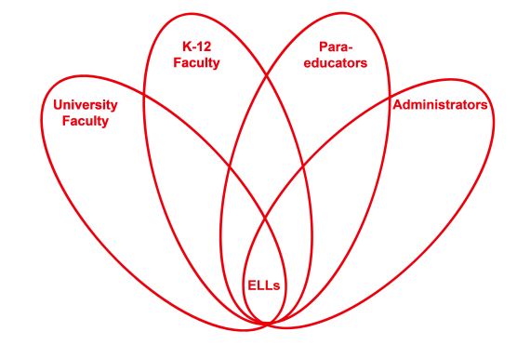

RETELL Strategy Implementation in the Classroom

Teacher | Melissa Carter
Content Area /  Grade Level | Health/ Gr.3
Unit  (Topic or Skill) | Bullying
Content Objectives | SWBAT: Describe what bullying is and identify ways in which someone can be bullied.
Language Objectives | CCSS.ELA-Literacy.W.3.3 Write narratives to develop real or imagined experiences or events using effective technique, descriptive details, and clear event sequences.  CCSS.ELA-Literacy.W.3.3a Establish a situation and introduce a narrator and/or characters; organize an event sequence that unfolds naturally.  CCSS.ELA-Literacy.W.3.3b Use dialogue and descriptions of actions, thoughts, and feelings to develop experiences and events or show the response of characters to situations.  CCSS.ELA-Literacy.L.3.5b Identify real-life connections between words and their use (e.g., describe people who are friendly or helpful).  SWBAT: Create a bullying cartoon which shows through pictures and speech bubbles how a person can be bullied.  Language Objective Differentiation for Proficiency Levels:  Levels 1&2  SWBAT: Draw pictures of bullying and label the bully and the victim in each drawing.
Strategy | Seven-Step Process for Pre-Teaching Vocabulary
Brief explanation of how the strategy was used | -Brainstorm what students think bullying is.  -Introduce vocabulary using the 7 step process for bully, victim, picking on, repetitive, intimidate, and worries.  -Read “Bullies Never Win” by Margery Cuyler. Highlight the vocabulary seen in the story. Use think alouds to make connections to the pre-taught vocabulary. Especially emphasize the word “worries” in the story because it is repeated throughout the story to capture how the victim feels.  -Discuss through think, pair, share who was the bully, the victim and how did you know. Talk about what ways the bully repeatedly try to intimidate her.  -Ask how would you feel if you were the girl in the story and what would you do if someone was bullying you.  -Turn and Talk to list ways someone can be bullied.  -Model and have students create their own cartoon story using speech bubbles or labels with a bully who repeatedly intimidates a victim in at least three different ways. Students will use class generated list to show different ways people are bullied.
Reflection: How and why was the strategy effective? What might you change for next time? | The seven step process for pre-teaching vocabulary was helpful because it gave my ELLs a background to understanding what bullying consists of. It also became clearer for them when they heard the terms within the context of the story because we had already touched upon those words in a variety of ways. The strategy helped the ELLs to produce academic language by making it easier for them to turn and talk with their peers in our discussion of the story. They were better able to comprehend the story and understand the concept of bullying.  The next time I try this strategy, I would like to do more role play. I would have my students act out being a bully, a victim and feeling worried. I would have them show what picking on someone actually looks like and what intimidation looks like too.

