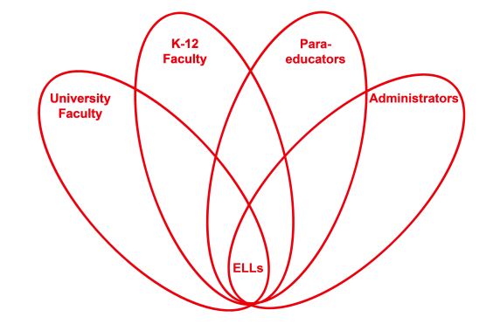

RETELL Strategy Implementation in the Classroom

Teacher | Paul Flanigan
Content Area /  Grade Level | Science Grade 5
Unit | Properties of Rocks and Minerals
Content Objectives | Students will be able to explain what a property is and give some examples.
Language Objectives | Students will be able to state properties of an object.
Strategy  (Name or Type) | Seven Step Process for Pre-teaching Vocabulary
Brief explanation of how the strategy was used | I went through the process for the “properties”. Afterwards,  we played the game “I Spy” which asked the students to identify properties of an object they saw in the room and share those properties orally with classmates. The other students then had a chance to identify the object based on its properties. This oral game provided multiple opportunities for the children to use both general properties and the specific ones we were discussing for rocks and minerals.
Reflection: How and why was the strategy effective? What might you change for next time? | The strategy itself worked well to introduce the word to the students because it provides so many opportunities for them to interact with the word.  The next time I try this strategy, I would practice the use of oral repetition with my students. It was quite obvious that I had never tried this technique with them as they did not repeat the word for me when prompted. I think that this is not a technique that we usually use at the middle school level because middle school students shy away from it. To make it effective, I clearly need to explain my expectations to them in the future and repeatedly use it. I would also practice the “activities to develop word/concept knowledge” myself as I found my examples were poor. I found the other parts relatively easy to come up with but not that part. I struggled to provide examples of how I would use it in a sentence.

