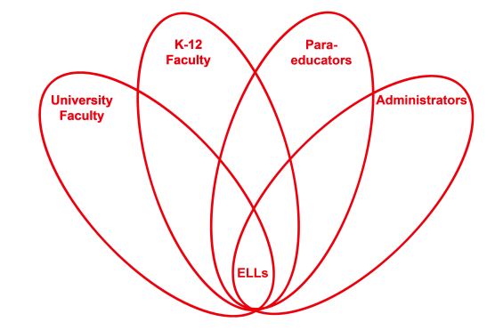

RETELL Strategy Implementation in the Classroom

Teacher | Carolyn Driscoll
Content Area /  Grade Level | ELA Grade 4
Unit | Holocaust/WWII
Content Objectives | 4 RL1  I can use details and examples in a text to explain and draw inferences.
Language Objectives | I can cite details and examples from the text when making inferences.  Language Objective Differentiation for Proficiency Levels:  Some of my ELLS will orally cite details and examples from the text and others will be able to write about the details.
Strategy | Seven Step Vocabulary
Brief explanation of how the strategy was used | I had a list of tier one, two and tier three words posted for the students. I chose the word anxious and briefly explained that I chose this word to help them understand why Grandma, a character in Lily’s Crossing, reacts in a particular way towards Lily. I went through the seven- step strategy with the students and they seemed very receptive to this strategy.  - Step 1: The word I am going to talk to you about today is anxious. Repeat THREE times.  - Step 2: Gram was standing at the edge of the ramp that led to the kitchen, smiling a little, looking anxious at the same time.  - Step 3: Anxious means afraid or nervous, especially about what may happen; feeling anxiety.  - Step 4: I think of anxious as being worried, nervous, or uneasy.  - Step 5: Anxious is an adjective but we also hear it used as an adverb when we hear: anxiously. For example, I anxiously awaited the arrival of my grandfather whom I hadn’t seen in years.  - Step 6: I feel anxious when ___________________________. I feel anxious when I have to speak in front of a large crowd. Turn to your partner and use this posted sentence frame to tell when you feel anxious. T-P-S and choose two or three students to share what they said or what their partner said.  - Step 7: This week in your journal, you will write about why Grandma was anxious when she was speaking with Lily in Chaper 5 of Lily’s Crossing.
Reflection: How and why was the strategy effective? What might you change for next time? | This strategy helped the ELLs in my class by exposing them to new vocabulary words and using them before reading these words in the text. All students in my class were able to use the new words in sentences and orally discuss with partners before seeing the word in the context of the text. This helped to increase their comprehension. It is important to expose students to vocabulary prior to reading a text in order to make the text more comprehensible.  This strategy provided the ELLs with explicit instruction of words they needed to be able to understand the text. It gave them some brief background knowledge and the opportunity to repeat the words by themselves and discuss them with partners. The ELLs will be able to use these words in both conversations as well as in their writing.  Next time, I think I would try to move my lesson along a little because I felt like it took a lot longer than I had expected. I also only felt I had time for a few students to share and the next time I would have more students share their sentences from the sentence frame.

