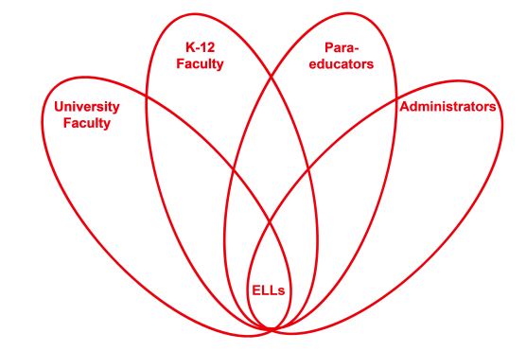

RETELL Strategy Implementation in the Classroom

Teacher | Andrew Larocque
Content Area /  Grade Level | Algebra 1/ Grade 9
Unit  (Topic or Skill) | CME: Algebra 1 Common Core  Lesson 3.12 Equations as Point-Testers, which is the second lesson of Investigation 3C Equations and their graph, which is the 3rd Investigation of Chapter 3 Graphs.
Content Objectives | SWBAT:  - Test a point to determine whether it is on the graph of an equation  - Write the equation of a vertical or horizontal line given its graph or a point on its graph
Language Objectives | - Students will read and analyze text, writing notes and definitions of point-tester and graph of an equation from the text book into their notebooks.  - Students will listen and explain orally to each other the process of graphing horizontal and vertical lines.
Strategy | 7-step Vocabulary Strategy
Brief explanation of how the strategy was used | The words that I chose to do the 7-step vocabulary strategy were satisfy, collection, test, and the phrase on the line. They are tier 2 words which means teaching them will make the bridge between tier 1 and tier 3 words. The content objectives were for students to determine whether a point is on the graph of an equation, however, the text used the word “satisfy” to ask the question. The question was, “Does the point satisfy the equation?” The text also wanted the students to test 6 different points on a line. The word test is polyesmous and in this situation it is being used to check points. Once they tested those points they would then determine that the line was either horizontal or negative and write an equation. That is why the word “collection” was chosen because it was used in understanding the definition of graph of an equation which is the collection of all the points that make the equation true. The key concept is if the point makes the equation true it is on the line. Using these strategies helped pre-teach the words that helped the students understand the major concepts of the lesson.
Reflection: How and why was the strategy effective? What might you change for next time? | The 7-step vocabulary strategy allows the students to improve their oracy by listening and speaking using these words. When the students read aloud they did not stumble over the chosen words. The students did not ask for clarification for the questions that included these words. The correct answers to the questions allowed me to infer they understood the questions. When the students spoke to one another explaining the process of graphing horizontal and vertical lines, they used the word test and the phrase on the line. These words that were chosen allowed the ELLs time to read, listen, speak, and write using the academic language of the classroom. It made all the students in the class think about the language that was being used and feel comfortable with the academic language. When the students came to the questions “Test 6 points of the equation” and “Does this point satisfy the equation” they were able to read and respond correctly making all the students especially the ELLs feel successful.  Next time I might change this part of the strategy. When writing the student friendly definition I would leave out words so that the students would have to fill in the blanks. This would create more ownership and make the students think about the words for themselves. When the students are asked to think of a situation with the word, they would do a Think-Write-Pair-Share. Then, I would ask if anyone would like to present their sentence using the word. This would incorporate all four domains and presenting in front of the class builds confidence and successful experiences.

