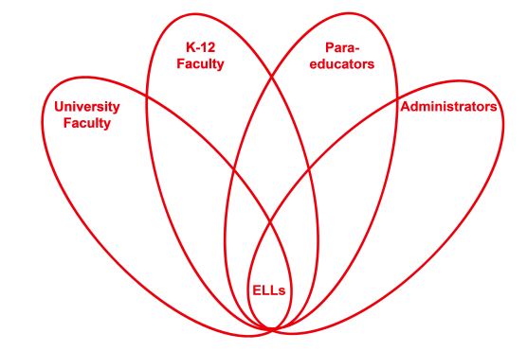

RETELL Strategy Implementation in the Classroom

Teacher | Elisha Jiyoon Ayala
Content Area /  Grade Level | 5th Grade Math
Unit  (Topic or Skill) | Identifying key words in word problems
Content Objectives | We will determine the correct operation in a word problem and calculate the answer.
Language Objectives | Students will discuss the key words and phrases in a word problem that help them determine the operation to use when calculating the answer.  Language Objective Differentiation for Proficiency Levels:  Level 1: Students will recite the words or phrases in a word problem that help them determine the operation to use when calculating the answer.  Level 4: Students will discuss the key words used in word problems that will help them determine the operation to use when writing the equation and calculating the answer.
Strategy  (Name or Type) | Word Wheel (modified for math class)
Brief explanation of how the strategy was used | I used the Word Wheel in my Math class to identify key words in word problems to help students determine what operation to use. I used a flower graphic organizer from www.edhelper.com. I thought using this graphic organizer was a better visual for students to use so that they could see the words “blooming” into words and phrases. The Word Wheel activity was used to launch the lesson. Students filled out the word wheel on their own first, discussed it with their small group, and then had a whole group discussion. The four operations in math were in the center. The first task was to write down all the key words used in word problems to help them determine the correct operation. The second task was then to write down the phrases and questions they would see in a word problem that would help them determine the operation to use when calculating the answer.
Reflection: How and why was the strategy effective? What might you change for next time? | This activity gave my ELLs the opportunity to explore the math academic language when it comes to solving word problems. If ELLs can identify these words, then they can feel more confident when solving a word problem. Using a glossary and a math cognates chart that I provide for my ELL students, they were able to see that the word total (el total) or the word sum (la suma) required them to add, or the word quotient (el cociente) requires them to divide, and the word difference (la differencia) requires them to subtract in a word problem.  My Level 1 ELL student decided to write the phrases in Spanish as well in English and during the discussion, they recited the words and phrases to their partner in both English and Spanish. My Level 4 ELL students were immersed in discussion and felt proud they were able to identify so many words on their own first before adding to their word wheel during whole group discussion.  The next time I try this strategy, I would have students sort words to match the operation (addition, subtraction, multiplication, division). I would also write the math cognates underneath the words in English so that my ELLs can build on their academic language in my class.

