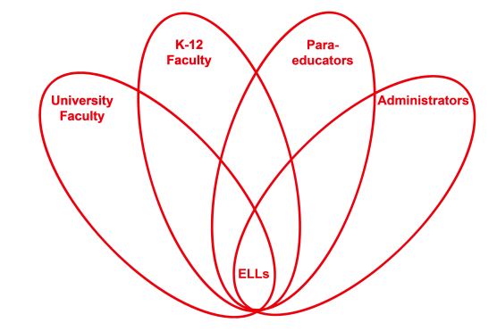

RETELL Strategy Implementation in the Classroom

Teacher | Susan AT Collins
Content Area /  Grade Level | Math/ Grade5 / Frost Middle School
Unit  (Topic or Skill) | Division
Content Objectives | Students will see how the use of the inverse operation will reinforce that they have the correct answer. This practice will become a daily part of solving equations.
Language Objectives | Language Objective: Students will discuss, observe, and demonstrate how the inverse operation works and why it is a great way to reinforce they have the correct answer.  Language Objective Differentiation for Proficiency Levels:  Level 3- Students will identify everyday uses of inverse, by reversing something or undoing something.  Level 4- Student will make a list of items that can be inversde, reversed or turned inside out.
Strategy | 7 Step Vocabulary
Brief explanation of how the strategy was used | After implementing the (7) step vocabulary strategy students were able to make clear connections and accurately answer questions related to the content objective. When all seven strategies were implemented, there was a significant increase in understanding for the ELLs. No one strategy was responsible; it was the result of all (7) steps being implemented effectively.
Reflection: How and why was the strategy effective? What might you change for next time? | Again, after implementing the (7) step vocabulary strategy students were able to  - See the words in print  - listen to the words spoken  - repeat the words orally  - pronounce the words accurately  - explain the meaning  - provide examples of the words: butter melting and kool-aid dissolving  - using a partner, complete the sentence starter and orally respond  - using a sentence frame, write a complete sentence with the new vocabulary words.

