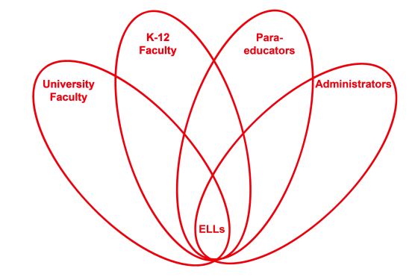

RETELL Strategy Implementation in the Classroom

Teacher | Susan AT Collins
Content Area /  Grade Level | Math/ Grade5/ Frost Middle School
Unit  (Topic or Skill) | Division
Content Objectives | Students will be able to self correct a division problem using the inverse operation.
Language Objectives | Language Objective: Students will be able to check their work using mathematical reasoning as well as proper terms that confirm their answer is accurate.  Language Objective Differentiation for Proficiency Levels:  Level 3- Students will work in groups to brainstorm terms associated with multiplication and then division. They are also able to recall theses terms by their prior work with word wheels. Then they will be able to report out orally to other groups. Students will all have the same terms and understanding of what these terms mean.  Level 4- Students will complete their lists of terms using their Vision book and or Math at Hand glossary.
Strategy  (Name or Type) | Language Experience Approach
Brief explanation of how the strategy was used | Procedure:  1. Students will solve to find the quotient of a division problem.  2. Using the solved problem the inverse operation will be worked through to prove that the quotient is correct.  3. Two lists will be developed: one for multiplication terms and the other of division terms. Students will remember our previous work with Word Wheels and be able to recall the terms.  4. Students will then plug in the needed terms to properly explain the inverse operation. This will prove that their division problem is correct.  Example: The inverse operation of division is multiplication. To check that a division problem is correct multiply the quotient by the divisor and add in the remainder, the product should be the dividend.  Taking time to analyze important terms is critical to overall understanding of the mathematical lesson. This strategy helped to make words clear as to what they mean. This strategy also helped to build a bridge between multiplication and division. Two very important skills that are often difficult to master as a young learner but easier to comprehend when interchanged. The ELLs are seeing the words, hearing the words, talking about the words and applying the words.
Reflection: How and why was the strategy effective? What might you change for next time? | The Language Experience Approach strategy helped the ELLs to become more familiar with these important vocabulary words and word families. These terms will continue to be used, needed and referred back to throughout mathematical learning. The way the student is able to plug and interchange the terms makes for a better understanding. The understanding is on the terms as well as their use in the skill of multiplication and division.  I would like to take one step back first. Yearly, I teach the inverse operation but give my students the terms. I find using this strategy is better for the comprehension for my ELLs. Next time I try this strategy I will put the development of the passage more on my students. They will take more of an active role in the explanation. Then I can remove the key terms to ensure students have comprehended each definition.

