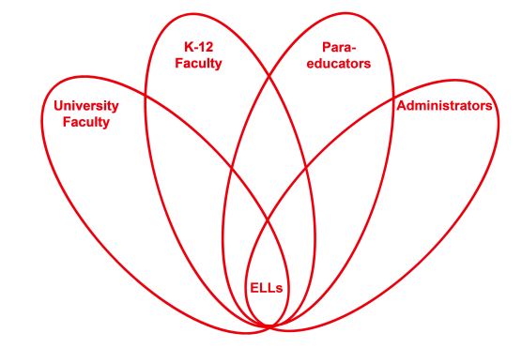

RETELL Strategy Implementation in the Classroom

Teacher | Susan Collins
Content Area /  Grade Level | 5th Grade Math
Unit | Using inverse operations (multiplication and division)
Content Objectives | Students will see how the use of the inverse operation will reinforce that they have the correct answer. This practice will become a daily part of solving equations.
Language Objectives | Students will discuss, observe, and demonstrate how the inverse operation works and why it is a great way to reinforce they have the correct answer.  Language Objective Differentiation for Proficiency Levels:  Level 3- Students will identify everyday uses of inverse, by reversing something or undoing something.  Level 4- Student will make a list of items that can be inverse, reversed or turned inside out.
Strategy | 7 Step Vocabulary Process
Brief explanation of how the strategy was used | Words Used: Inverse Operation  1. Present the word in writing.  2. Pronounce the word and have students read & pronounce the word several times.  3. Clarify the part of speech and specify whether it is formal, high use, rare etc.  4. Explain the meaning using familiar language, drawing upon synonyms if possible.  5. Provide 2 concrete examples that enable students to create vibrant mental anchors.  6. Actively engage students with the word by assigning a brief partner application task.  7. Assign a sentence frame to guide application of word knowledge to a new context.
Reflection: How and why was the strategy effective? What might you change for next time? | After my implementation of the (7) step vocabulary strategy, students were able to make clear connections and accurately answer questions related to the content objective. When all seven strategies were implemented, there was a significant increase in understanding for the ELLs. No one strategy was responsible, it was the result of all (7) steps being implemented effectively. Next time, I would involve the whole class. I was trying to be discrete, but next time I would involve the whole class and encourage the ELLs by having the class clap to accurate responses etc. It was such an effective strategy, everyone could/would benefit from being involved.

