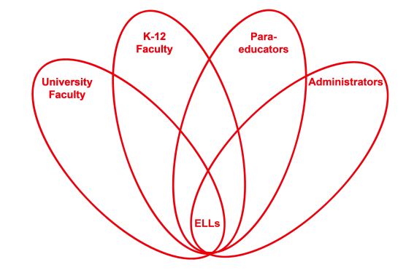

RETELL Strategy Implementation in the Classroom

Teacher | JiYoon Elisha Ayala
Content Area /  Grade Level | 5th Grade Math
Unit  (Topic or Skill) | Adding and subtracting fractions and mixed numbers with unlike denominators.
Content Objectives | Students will add and subtract fractions with unlike denominators.
Language Objectives | You will explain how to find a common denominator when adding and subtracting fractions with unlike denominators.  Language Objective Differentiation for Proficiency Levels:  Level 1: Students will label fractions with the correct vocabulary word.  Level 3: Students will describe how to find a common denominator by completing the sentence starter using the correct words from word bank.  Level 5: Students will explain how to find common denominators when adding and subtracting fractions with unlike denominators using all the vocabulary words.
Strategy  (Name or Type) | 7-Step Vocabulary Process
Brief explanation of how the strategy was used | ELLs in my classroom were able to preview the academic vocabulary words. This strategy allowed me to review the words they would be required to use in my class. As I was stating the vocabulary words, I pointed to the different parts of the fraction so my ELLs could visualize the vocabulary words as well. Students also had the opportunity to use the academic language class when they turn and talk to their partners or when they completed the sentence starter using the academic vocabulary words from the word bank. The repetition of the vocabulary words helped to make the content comprehensible to the ELLs in my classroom. Seeing the process over and over and hearing the same sentence (ie. to find a common denominator, you multiply the denominators) also made the content comprehensible to my students.
Reflection: How and why was the strategy effective? What might you change for next time? | This strategy allowed my students to practice using the academic language. Students were asked to write down the sentence starter with the correct vocabulary words and then they were able to turn and talk to their partner. I made sure to give students the vocabulary words I expect them to use throughout the class. This helped ELLs maintain focus on language development. They were clear on what the language objective required them to do. The repetition of the academic language throughout the class and the sentence starters provided my ELLs oral practice using the academic language.  The next time I try this strategy, I would use the clock buddy activity and have the students find a partner at 3, 6, and 9 o’clock to repeat their completed sentence starter. It always helps to repeat something multiple times to memorize it!

If you created any handouts, presentations, or other materials to implement the strategy in the classroom and to support English language learners, please include those as well so we can share them with other teachers.

Please send this form and any additional materials as attachments to emilymrobichaud@gmail.com

