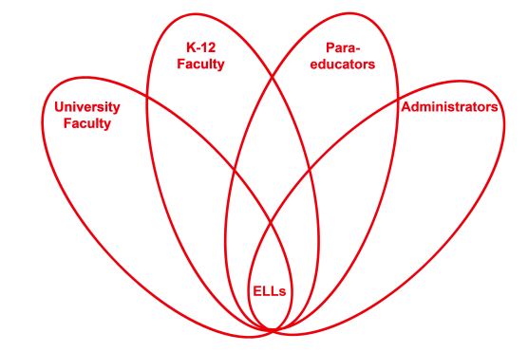

RETELL Strategy Implementation in the Classroom

Teacher | Susan AT Collins
Content Area /  Grade Level | Language Arts/ Grade 5
Unit  (Topic or Skill) | Theme: Social Justice – Student will identify the type of injustices encountered in reading (unfair treatment, violence, poverty, etc.). This is a book used in our LA Enrichment class.  Text: Two Tickets to Freedom, by Florence B. Freedman  Do Now: Explain the difference between ‘human rights’ and ‘civil rights’.  Essential Question: What is the social injustice in our reading and why do people risk their lives to challenge this injustice?  (Acceptable responses: racial inequality, unfair treatment of blacks and people fight back or risk their lives for change)
Content Objectives | Content Objective:  Students will be able to explain what led up to black families running for freedom.  (Students will utilize the Think-aloud Strategy)
Language Objectives | Language Objective:  Students will improve reading comprehension and discourse through the use of the think-aloud strategy.  Language Objective Differentiation for Proficiency Levels:  Level 3 - The student will observe the teacher and his/her partner practicing the think-aloud technique. Student will offer answers to teacher’s questions.  Level 4 – The student will practice the think-aloud technique by asking appropriate questions aloud and answering the question aloud.
Strategy | Think-aloud
Brief explanation of how the strategy was used | This think-aloud strategy helped my readers to comprehend more easily what was being read. It was used to increase student comprehension and independence. The students verbalized their thoughts and thus, brought into the open, the strategies they were using to understand the text. Students were learning to question themselves during their reading and be consistently formulating questions. Through the interactions (discussions) that the think- aloud promotes, a better understanding of the text emerged. It is in this way that students were learning to monitor their own comprehension. This strategy was very useful because students were verbalizing all their thoughts in order to understand the reading. These thoughts might include commenting on or questioning the text, bringing in their prior knowledge, or making inferences or predictions. These comments revealed student weaknesses as well as their strengths for comprehending and allowed me, the teacher, to assess their needs and plan for more effective instruction.
Reflection: How and why was the strategy effective? What might you change for next time? | The think- aloud strategy promoted much teacher – student interaction because we were working together to construct understanding of text. The think-aloud required students to ‘report out’ their thoughts while reading so there was a lot of academic language (discourse) in the process. The discourse allowed us to talk about the text and make connections between prior knowledge and the text. The content of the book is very high interest, so discourse about the text was easy. The students love this unit of study so discourse and dialogue using academic language seems to be the natural course. For many, the questions they verbalized were of a much higher level than I expected. The long term benefit of the think-aloud strategy is that the student will gradually learn to internalize the dialogue and it will eventually become their inner speech.

