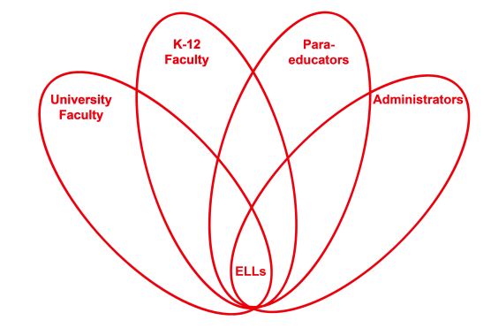

RETELL Strategy Implementation in the Classroom

Teacher | Jenna Ward
Content Area /  Grade Level | ELA Grade 5
Unit  (Topic or Skill) | Explorers: Magellan
Content Objectives | I will describe the challenges faced by the crew of Ferdinand Magellan during their expedition to find a new route to the Moluccas Islands.
Language Objectives | I will summarize, in writing, the challenges faced by the crew of Ferdinand Magellan during their expedition to find a new route to the Moluccas Islands.  Level One: I will answer simple questions about the challenges faced by the crew of Ferdinand Magellan with single words.  Level Two: I will make lists of details about the challenges faced by the crew of Ferdinand Magellan.  Level Three: I will describe the challenges faced by the crew of Ferdinand Magellan with a simple expository paragraph.  Level Four: I will summarize the challenges faced by the crew of Ferdinand Magellan in an expository paragraph.  Levels Five-Six: I will produce an extended response summary of the challenges faced by the crew of Ferdinand Magellan.
Strategy  (Name or Type) | Write Around
Brief explanation of how the strategy was used | After brainstorming as a whole group, students respond in small groups to the following prompt:  In a well-written and detailed paragraph, describe the challenges faced by Magellan’s crew on his expedition to find a new route to the Moluccas Islands.  Students work in groups of three or four to respond to the question. The first student writes first and passes the paper to the left after one minute. The groups write for a total of twelve minutes so that each student has at least three turns.
Reflection: How and why was the strategy effective? What might you change for next time? | This strategy worked well to make the content comprehensible to ELL students because it allowed them to slow down and spend some time focusing on just one element of the story we were reading in order to understand its effect on the outcome. Because the strategy forced students to focus all of their energy and thinking power on thinking about the difficulties encountered by Magellan’s crew, students were more easily able to imagine what it would have been like to be a member of the crew and why some members chose to rebel. Additionally, because the strategy is used in a cooperative group setting, students were reminded of challenges the crew faced that they may not have remembered on their own. To increase my ELLs’ engagement and interaction, the next time I try this strategy, I would add some time in during which the students can edit and revise their paragraphs as a group. While I think this activity worked well as is, I did notice that the paragraphs that were produced were not examples of well organized writing, likely due to the time constraints and rushed atmosphere of the activity. I think using some time after the time for the write around is up to model how to check for proper organization, question restating, and conclusion statements would be of a great benefit to the students if they were then allowed to go back and revise their own with help from their teammates.

