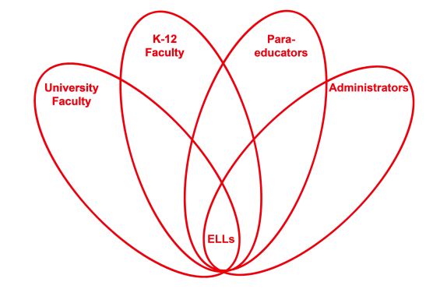

RETELL Strategy Implementation in the Classroom

Teacher | Jenna Ward
Content Area /  Grade Level | ELA Grade 5
Unit  (Topic or Skill) | Explorers
Content Objectives | Students will explain the causes and effects of ocean exploration.
Language Objectives | Students will compose a paragraph that details the causes and effects of ocean exploration.  Level One: Students will communicate their ideas about one cause and one effect of ocean exploration by drawing a picture of each.  Level Two: Students will list, in writing, the causes and effects of ocean exploration.  Level Three: Students will describe, with simple written sentences, the causes and effects of ocean exploration.  Level Four: Students will summarize, in a simple written paragraph, the causes and effects of ocean exploration.  Levels Five – Six: Students will write an extended response in which they summarize the causes and effects of ocean exploration.
Strategy  (Name or Type) | Word Wheel
Brief explanation of how the strategy was used | In order to implement the word wheel strategy, I:  - Defined the word “explore” for students using the previously learned seven step process.  - Taught the students derived forms of the word “explore” such as explorers, exploration, and exploratory.  - Asked the students to think about and list synonyms for the word “explore.”  - Displayed a word wheel on the board with the following words used as synonyms: investigate, research, inspect, survey, examine.  - Discussed with the students how each word is similar to the word “explore.”
Reflection: How and why was the strategy effective? What might you change for next time? | I think this strategy was helpful in making the content comprehensible for ELL students in my classroom for two reasons. First, if the students were unfamiliar with the word explore, seeing synonyms for the word increased the likelihood that they would understand my explanation and definition of explore. Second, if the students did understand the word explore after hearing my seven step introduction and seeing the displayed pictures, they had the opportunity to learn up to five new words by studying and discussing the word wheel. To increase my ELLs’ engagement and interaction, the next time I try this strategy, I would ask students to choose one of the words on the word wheel and complete a Frayer model with the word, draw a picture of the word, or write a paragraph (or sentence or fill in a sentence frame, depending in his or her level) using the word. I think that allowing the students this additional interaction with one of the words would enhance understanding of both the chosen synonym as well as the original word, explore. Such an activity would also stand to activate students’ thinking skills and prior knowledge related to the concept of exploring.

