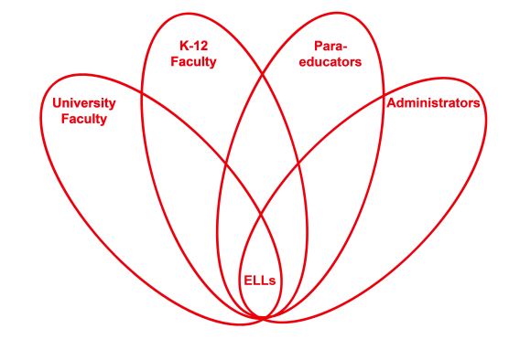

RETELL Strategy Implementation in the Classroom

Teacher | Jenna Ward
Content Area /  Grade Level | ELA Grade 5
Unit  (Topic or Skill) | Explorers
Content Objectives | Students will describe the causes and effects of exploring the remains of the Titanic.
Language Objectives | Students will write a paragraph to describe the causes and effects of changes to the remains of the Titanic.  Level One: Students will answer oral questions with short, single word responses about one cause and one effect of changes to the remains of the Titanic.  Level Two: Students will list, in writing, the causes and effects of changes to the remains of the Titanic.  Level Three: Students will describe, with simple written sentences, the causes and effects of changes to the remains of the Titanic.  Level Four: Students will summarize, in a simple written paragraph, the causes and effects of changes to the remains of the Titanic.  Levels Five – Six: Students will write an extended response in which they summarize the causes and effects of changes to the remains of the Titanic.
Strategy  (Name or Type) | Think Aloud
Brief explanation of how the strategy was used | The italicized font in parentheses below is my think aloud that I added to the text selection.  Now, we are going to read a first-hand account from someone who was on the Titanic when it crashed into the iceberg. A first-hand account, also called an eyewitness account and sometimes a primary source, is something written by a person who experienced an event himself. While I read, try to think about what extra information a reader can get about the Titanic from reading this account.  “This is an eyewitness account from 8-year-old Marshall Drew, who was traveling with this aunt and uncle. ‘When the Titanic struck the iceberg, I was in bed. (I am wondering what time of day it was that the Titanic crashed. I guess since Marshall was in bed, it was probably the middle of the night.) However, for whatever reason I was awake and remember the jolt and cessation of motion. (Hmm…I know that cessation means a stop, so he must have felt the ship come to a sudden stop. I bet that made him bounce back a bit. [show sudden stopping motion.])A steward knocked on the stateroom door and directed us to get dressed, put on life preservers and go to the boat deck, which we did…All was calm and orderly. An officer was in charge. ‘Women and children first,’ he said as he directed lifeboat number 11 to be filled. There were many tearful farewells. We and Uncle Jim said goodbye (I can’t believe how sad it must have been for Marshall to have to say goodbye to his uncle. The rule that women and children had to go on the lifeboat first must be the reason they couldn’t stay together. I know Marshall survived since he is telling us about his time on the Titanic, but I wonder what happened to his uncle.)…The lowering of the lifeboat 70 feet to the sea was perilous …Nothing worked properly, so that first one end of the lifeboat was tilted up and then far down. (Perilous means dangerous. I think since everything was broken and not working properly, it must have been dangerous trying to get on the lifeboat.) I think it was the only time I was scared... When the Titanic upended to sink (I can break apart the word upended to figure out what it means. I think it must be talking about how one end of the ship was up in the air. [show arm motion of upending.]), all was blacked out until the tons of machinery crashed to the bow…As this happened hundreds and hundreds of people were thrown into the sea. It isn’t likely I shall ever forget the screams of these people as they perished in water said to be 28 degrees. (Wow! That is very cold water!).’”  Source for Text: Scholastic’s Navigating Nonfiction Grade 5
Reflection: How and why was the strategy effective? What might you change for next time? | This strategy was very helpful in making the content comprehensible to ELLs in my classroom. Hearing the text read aloud can help them to follow along with the reading as is, but seeing me stop and demonstrate the way I think about what I’m reading, like when I realized I needed to break apart the word “upended” in order to figure out what the sentence meant, can help them to learn strategies to use in their own reading. Likewise, seeing me stop and think about the feeling of cessation that Marshall felt helped the students understand what it would have been like to be on the ship at the time it hit the iceberg. Overall, the strategy of read aloud really demonstrates to students that when we read, we read for meaning not just for decoding. As a result of the think aloud, students were also exposed to new vocabulary words such as cessation, perilous, and upended, which they are very likely to see in future reading. To increase my ELLs’ engagement and interaction, the next time I try this strategy, I would add in some physical activity. For example, when I stop to think about what “cessation” means, I could ask the students to move their bodies in the way that they might have been forced to if they were on the ship when it came to a sudden stop. I think I could also use some student volunteers to come to the front of the class and represent Marshall, his aunt, and his uncle so that the students can see with their eyes that the family had to separate because of the rule that women and children needed to board the lifeboat first. Adding visuals and motions would not only increase engagement, but would definitely increase understanding as well.

