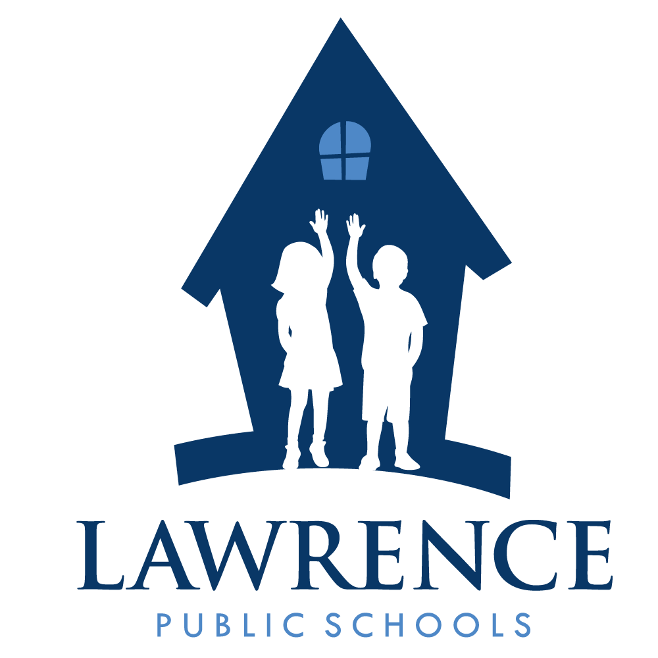
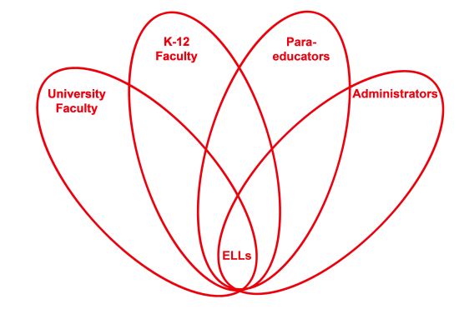

RETELL Strategy Implementation in the Classroom

Teacher | Susan AT Collins
Content Area /  Grade Level | Language Arts/ Grade5
Unit  (Topic or Skill) | Text Features: Book Cover, Table of Contents and Pictures.
Content Objectives | Students will understand the impact, dangers and emotional turmoil that fugitive slaves experienced.  Theme: Social Justice – Student will identify the type of injustices encountered in reading(unfair treatment, violence, poverty, etc.). This is an interdisciplinary unit for ELA, Humanities and Reading.  Text: Two Tickets To Freedom: by Florence B. Freedman
Language Objectives | Student will improve reading comprehension by analyzing text features in the book, Two Tickets To Freedom.  Language Objective Differentiation for Proficiency Levels:  Level 3 - The students will discuss the illustrations and then orally pose questions regarding what they understood and what they did not understand.  Level 4 – The students will discuss the text features and then write questions on sticky notes, regarding what they understood and what they did not understand.
Strategy  (Name or Type) | Text Features: Book Cover, Table of Contents and Pictures.
Brief explanation of how the strategy was used | The students analyze the book cover. They look at the table of contents describing the chapters in the book. Most of the chapters focus on places our young fugitive slaves Ellen and William Craft traveled. We look at the many freehand sketches that the author incorporated into this book. These illustrations will help us to make a mind movie about what is to be expected. The pictures are dark and unclear showing the view from our fugitives eyes.  This was an excellent strategy to implement with the students for a number of reasons. First, it takes the stress out of the ‘unknown’. We just completed the word wheel as a strategy for vocabulary. Now, we take our time and look at the book cover and try to extract information from the picture. This creates an atmosphere of ongoing discussion and critical analysis. Students always have some anxiety about starting a new book and this strategy works well to reduce that anxiety and give the student a chance to absorb the information and think about the kind of story they are about to read. The students can then talk about key points in the photo they believe, relate to the story. Students are very good at reading into the illustrations and drawing their own conclusions.  Next, we opened the book and read the table of contents. This was a good opportunity to get a sneak peek at where the slave fugitives were going and where they got detained. The table of contents described the introduction and the several locations Ellen and William traveled to before finally getting to freedom. Some chapters focused on locations and landmarks that are close and or familiar to us. This gave us a chance to tap into some prior knowledge as well. I used this opportunity to map out the traveling location of our characters as they traveled up North to freedom.  Then we took some time to view the carefully selected, spectacular, black and white sketches. The pictures are very telling of the times and tell a story all on their own. You get a clear sense of the injustices looking at these pictures. The students are really involved and very inquisitive about the illustrations. They are beginning to question what they see and make predictions.
Reflection: How and why was the strategy effective? What might you change for next time? | In reviewing the contents and the illustrations, we discussed and shared our background knowledge. While we talked I took every opportunity to use academic language and develop the vocabulary associated with this book. The more I used it, the more they used it. Discourse is language use because it promotes vocabulary development and comprehension. Before we even start reading, the vocabulary words are used multiple times, each. Civil rights and the whole concept of injustice is so rich in opportunity for discussion and the more we partake in discussion the greater the opportunity we have to use the language.  I would like to bring in more illustrations, books and other materials to paint a better mind movie for my students. I felt their curiosity was ignited and I needed to keep the flame alive. I know that in January I will continue to build on their knowledge with an easy reading book I have called, “My friend Martin”. This book also has a brief cartoon movie that goes with it. It is a child friendly look at the life and accomplishments of Martin Luther King, Jr. Yearly I find that my students like this mini lesson.

