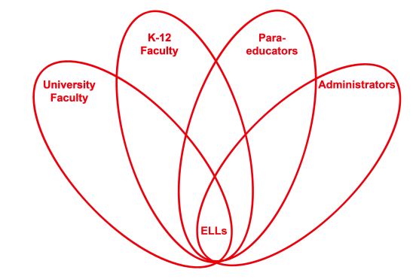

RETELL Strategy Implementation in the Classroom

Teacher | Jenna Ward
Content Area /  Grade Level | ELA Grade 5
Unit  (Topic or Skill) | Explorers: Ferdinand Magellan
Content Objectives | Students will be able to explain how Ferdinand Magellan prepared for his expedition.
Language Objectives | Students will write a persuasive letter from the point of view of Ferdinand Magellan in which he highlights how prepared he was for his journey.  Level One: Students will copy words and phrases from the text into a template for a persuasive letter from the point of view of Ferdinand Magellan in which he highlights how prepared he was for his journey.  Level Two: Students will fill in a graphic organizer with details from the text to write into a persuasive letter from the point of view of Ferdinand Magellan in which he highlights how prepared he was for his journey.  Level Three: Students will describe the processes used to prepare for an expedition in a persuasive letter from the point of view of Ferdinand Magellan in which he highlights how prepared he was for his journey.  Level Four: Students will explain how Magellan used problem solving skills in order to ensure safety in a persuasive letter from the point of view of Ferdinand Magellan in which he highlights how prepared he was for his journey.  Levels Five-Six: Students will write an extended response persuasive letter from the point of view of Ferdinand Magellan in which he highlights how prepared he was for his journey.
Strategy  (Name or Type) | RAFT Writing (Role, Audience, Format, Topic)
Brief explanation of how the strategy was used | Role: Magellan  Audience: Men in Spain  Format: Persuasive Letter  Topic: Convincing the men it is safe to join your expedition crew  Students were given an exemplar of a finished letter for this assignment. They were also shown how to create a graphic organizer to plan at least three reasons Magellan could use to convince them it would be safe to join him, as well as to plan what additional details they might pull out of the text.
Reflection: How and why was the strategy effective? What might you change for next time? | Students had already read the chapter that details how prepared Magellan was, but due to the importance of this information, they needed the opportunity to interact with this information in order to better learn and remember it. Asking the students to pretend they were Magellan allowed them to view the content from a unique perspective and see how hard he tried to prepare for the journey, in contrast to some of the other explorers they had read about in humanities class. The RAFT assignment allowed them time and a purpose to really think through what it meant to be prepared in the 1500s and how the time period was so different from our own. I think that this strategy worked very well the way it was done, and I intend to use it in the future. It is a great way to be sure we cover the three main types of writing for Common Core (narrative, persuasive, informational) and keep students engaged. As far as using it with persuasive writing goes, I think that next time I will have the students share their writing aloud with the class and then have the class vote on whether they would be convinced or not and discuss why. This will allow students to have interaction not only with their own writing, but with the writing of their peers. I think they would be very excited about the prospect of trying to convince their friends to do something!

