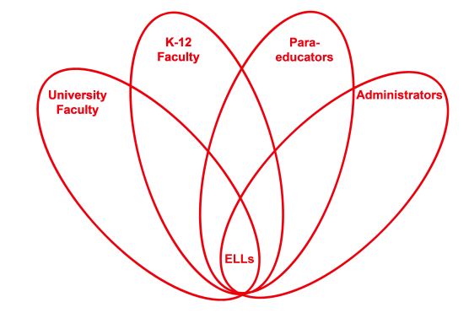

RETELL Strategy Implementation in the Classroom

Teacher | Jenna Ward
Content Area /  Grade Level | ELA Grade 5
Unit  (Topic or Skill) | Explorers: Ferdinand Magellan
Content Objectives | I will describe the outcomes of the life and expedition of Ferdinand Magellan.
Language Objectives | I will summarize, in writing, the life and expedition of Ferdinand Magellan.  Level One: I will answer simple questions about the life and expedition of Ferdinand Magellan with single words.  Level Two: I will make lists of details about the life and expedition of Ferdinand Magellan.  Level Three: I will describe the life of Ferdinand Magellan and the events during his expedition with a simple expository paragraph.  Level Four: I will summarize the life and expedition of Ferdinand Magellan in an expository paragraph.  Levels Five-Six: I will produce an extended response summary of the life and expedition of Ferdinand Magellan.
Strategy  (Name or Type) | Double-Entry Journal
Brief explanation of how the strategy was used | I used the strategy of double-entry journals for my introductory lesson to this text, and I plan to continue using it throughout the duration of our reading the story. Although I kept the basic structure of the double-entry journal, I did modify the procedures of the strategy to better fit the needs of my students.  - I chose four quotations from chapter one that I felt encompassed the central and most important ideas in the text, which also happened to be the ideas that I wanted students to remember as we move forward in our reading. I typed the four quotations up and printed them so that I could give each student a copy.  - I modeled for each student how to tape the sheet of quotations into their notebook, explaining that it needed to be taped all the way over to the left so that they could use the right side to respond.  - I posted a picture on the mimio board of a model double-entry journal so they could see what the finished product should look like as well as how I chose to respond to the quotations myself.  - I instructed students to respond to the quotations in any way: ask a question, summarize the meaning, agree or disagree, make a prediction, etc.  - Students spent the remainder of class responding on the right side of their notebooks to the quotations I selected.
Reflection: How and why was the strategy effective? What might you change for next time? | This strategy was very helpful in making the content comprehensible to ELLs in my classroom because although they were responsible for listening to and reading the entire chapter, they were only required to wrestle with and make meaning out of small chunks of important texts. This allowed them to slow down their reading and really focus only on what was important, giving them more time to exercise their critical thinking skills. I think it also served to encourage the students to take more risks since the journals allow them to respond in any way they choose, there is a limited risk of producing a wrong answer, which serves as a confidence booster. To increase my ELLs’ engagement and interaction, the next time I try this strategy, I would allow for cooperative work while filling in the right side of the double-entry journal. I think it would be beneficial to all students, but especially ELL students, to be able to hear the ideas that their classmates have and to share their thinking. Although all students were successful with this strategy the way it was implemented, I imagine that using cooperative work in addition would encourage the students to produce even more written reaction to the quotations. Also, to increase interaction with the text, in the future, I will allow students to choose their own quotations to respond to, but only after they have become completely comfortable with the process of double-entry journals.

