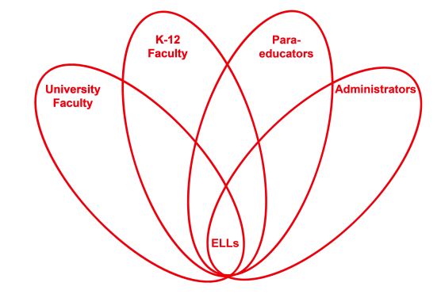

RETELL Strategy Implementation in the Classroom

Teacher | Susan AT Collins
Content Area /  Grade Level | Language Arts/ Grade5/
Unit  (Topic or Skill) | Chapter summaries of The Lion, The Witch and The Wardrobe by C.S. Lewis
Content Objectives | Content Objective: Using the novel The Lion, The Witch and The Wardrobe” by C.S. Lewis we will use the ‘cut and grow” method to summarize each chapter.
Language Objectives | Students will be able to check, correct and rewrite their work using the “cut and grow” strategy. Students will be able to expand upon ideas to develop a topic.  Language Objective Differentiation for Proficiency Levels:  Level 3- Students will work in groups to brainstorm terms and ideas associated with their topic. They are also able to recall these ideas by their prior work. Then they will be able to report out orally to other groups.  Level 4- Students will be able to go back over their text for key ideas and terms that they would like to write in their paper.
Strategy  (Name or Type) | Cut and Grow
Brief explanation of how the strategy was used | Procedure:  1. The writer selects a sentence in their paper that they would like to improve.  2. They use scissors and cut the selected sentence out of the paper, then tape the top half of their paper onto a piece of construction paper and create an improved sentence to write on the construction paper.  3. Once the sentence is written, they attach the rest of their paper.  This strategy can be done several times to show the student how they can always improve and grow in their writing.
Reflection: How and why was the strategy effective? What might you change for next time? | This method provides a visual of how to substitute one sentence for another. This is valuable for ELLs because they can see their paper actually grow. The Cut and Grow Strategy helped to produce academic language and discourse through the adding, revising and restructuring of the students writing. The students felt pride in the development and progress in their work. It is also a good way for peers to practicing revising and editing each other’s work.  To increase my ELLs’ engagement and interaction, the next time I try this strategy, I would have students only work on their own writing and then have their peer edit at the very end. I felt each student was strong enough to edit and correct their own work. A final peer edit does not need to happen until the very end.

