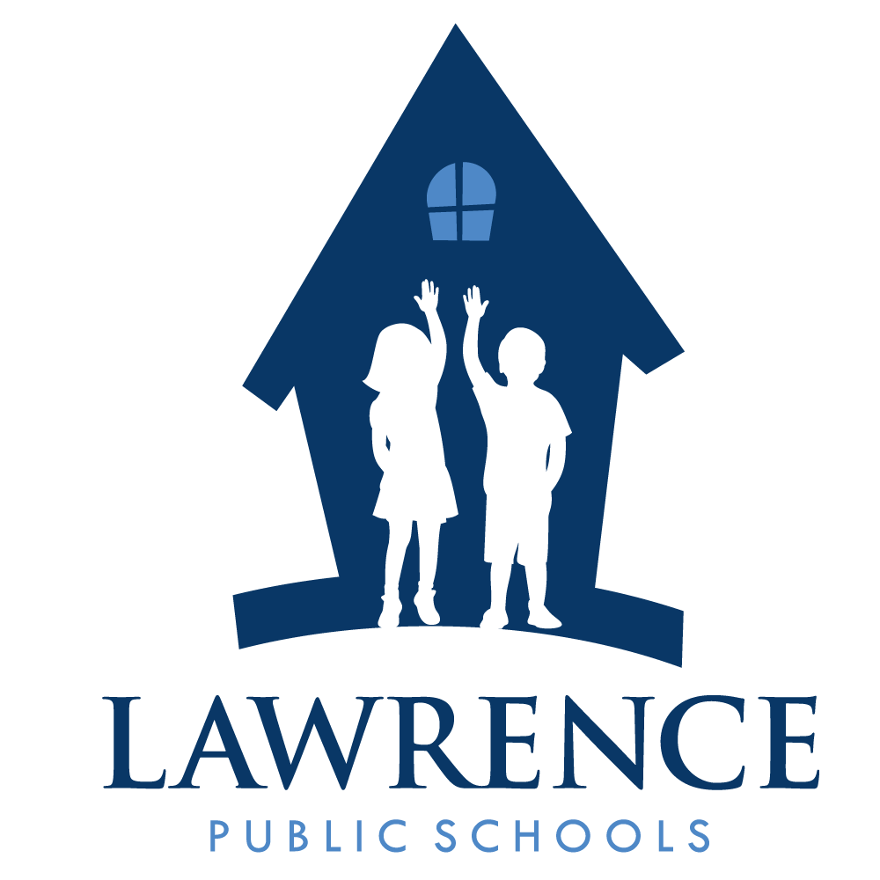
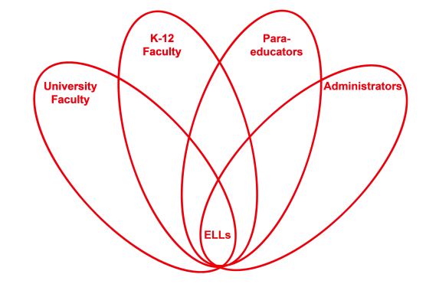

RETELL Strategy Implementation in the Classroom

Teacher | Jenna Ward
Content Area /  Grade Level | ELA Grade 5
Unit | Academic Vocabulary / “Communicating Culture”
Content Objectives | I will identify the conflict, resolution, and theme of the story, “Communicating Culture.”
Language Objectives | I will summarize, in writing, the story “Communicating Culture.”  I will discuss how the characters overcome the challenges they face in the story.  Level One:  I will communicate what I know about the conflict and resolution of the story by drawing a picture.  I will name the characters in the story who are afraid to give up their native culture and those who are able to integrate their native culture with their new one.  Level Two:  I will complete sentences that summarize the story by identifying what the conflict is and what the resolution is.  I will share information with my peers about how my feelings about my culture are similar to those of the characters.  Level Three:  I will produce simple sentences about the conflict and the resolution of the story by describing what happens to the characters.  I will present information about the conflict and resolution of the story to my peers in a discussion.  Level Four:  I will summarize the story by identifying the conflict and resolution.  I will discuss the story and the issue of losing one’s culture with my peers.  Level Five:  I will summarize the story by identifying the conflict and resolution.  I will discuss the theme of the story using textual evidence while connecting my personal experiences to those of the characters.
Strategy | Seven-Step Process for Pre-Teaching Vocabulary
Brief explanation of how the strategy was used | - I said the word “culture” and asked the students to repeat three times.  - I introduced the word in context by saying, “In the story, Mr. Puente has a hard time because he is afraid he is going to lose his Dominican culture if he learns English.”  - I used the dictionary definition of the word to explain that culture is the beliefs, customs, and arts of certain groups of people.  - I then explained using a student friendly explanation that your culture is the foods you like to eat, the music you like to listen to, and the holidays you celebrate with your family. At this point, a student prompted me to use the word “background” to explain, so I added that in to my explanation.  - I provided the students with two concrete examples of the word culture by explaining that my family is partly Italian and so part of our culture is to eat Italian food, like spaghetti and meatballs. I also explained that many students who grow up in urban, or city, American environments, might enjoy hip hop music as a part of their culture.  - I then gave the students a chance to interact with the word by calling on them to share examples from their own culture. If they were stuck, I prompted them by asking “what type of food do people in your culture like to eat?” or “what types of dances are there in your culture?”  - I then assigned the students to read the story “Communicating Culture” and asked them to notice how Mr. Puente feels about his culture at the beginning of the story compared to the end.
Reflection: How and why was the strategy effective? What might you change for next time? | Pre-teaching the word culture made the content comprehensible to the ELLs in my classroom because it allowed for them to connect to the story and its characters, as well put their academic vocabulary that they had learned and practiced with flashcards to use. Culture came up often in the story, so students could read it more easily. Additionally, they had the opportunity to speak about their own cultures and listen to their classmates speak about theirs. After reading the story, they could even write a short summary of the story since both the conflict and resolution revolved around the world culture. To increase my ELLs’ engagement and interaction, the next time I try this strategy, I would use visuals to aid in delivering the meaning of the word, in this case, culture. For example, I might show pictures of foods from different cultures, dances from different cultures, and maybe even play music clips from different cultures. This would bring more meaning to the word, especially to the newcomers who struggled to understand the student friendly explanation of the words and the examples and discussion that followed.

