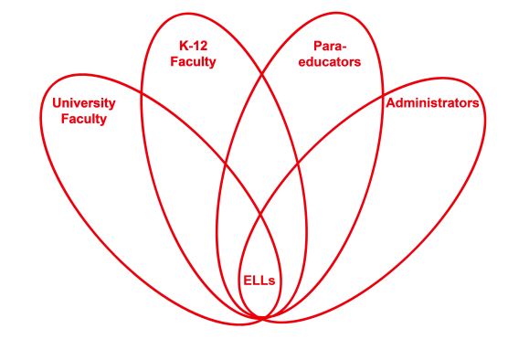

RETELL Strategy Implementation in the Classroom

Teacher | Carlene Hackett
Content Area /  Grade Level | Reading/Social Studies  Grade 4
Unit  (Topic or Skill) | Westward Expansion
Content Objectives | Students will refer to details and examples in a text when explaining what the text says.
Language Objectives | Students will use the text to describe the events during the Westward Expansion.
Strategy | Double Entry Journal
Brief explanation of how the strategy was used | This strategy was used weekly during the reading of “Little House on the Prairie”. It was a good tool to use for class discussions as well as comprehension assessment.  Students were told to take one sentence from the text from today’s reading and write it on the left side of the journal paper, on the right hand side they are told to write their thoughts about that part of the text or an “I wonder”.
Reflection: How and why was the strategy effective? What might you change for next time? | This strategy was very effective; it had all the students looking at the text with more of a critical mind. Many times the text that was used by students was shared to each other as a class or using partners.  Next time I might expand this strategy in other content areas.

