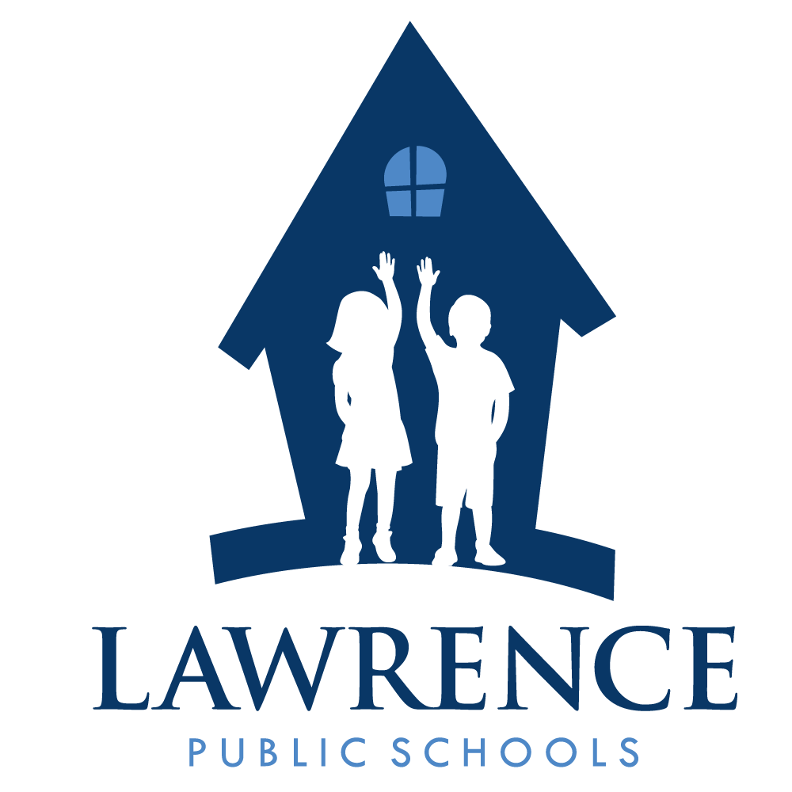
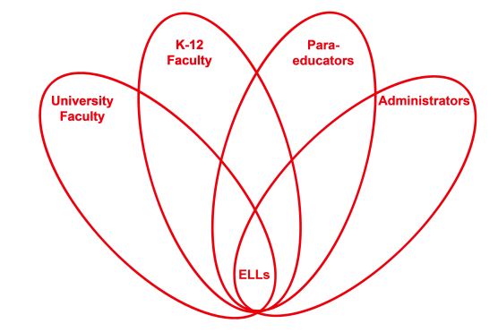

RETELL Strategy Implementation in the Classroom

Teacher | Anne Blanchette
Content Area /  Grade Level | Grade 1 Writing
Unit  (Topic or Skill) | Thanksgiving
Content Objectives | 1.W.5 SWBAT: Focus on a topic, respond to questions and suggestions from peers, and add details to strengthen writing as needed.
Language Objectives | SWBAT: Discuss and write a response to the question: Would you rather live as a Pilgrim or a Native American?  Level 1: Repeat simple phrases about Native Americans and Pilgrims.  Draw pictures of Pilgrims and Native Americans.  Level 2: Repeat facts or statements about Pilgrims and Native Americans.  Complete modeled sentence frames. Example: I would like to live like a ___________________because…  Level 3: Retell simple stories from picture cues. Example: Selected pages from the book New Friends in a New Land by Judith Bauer Stamper.  Level 5: Use academic vocabulary in class discussions. Example: Tell about the Pilgrims and Native Americans.
Strategy  (Name or Type) | Word Wheel: Native American  Words and phrases generated: Indians, Taught Pilgrims how to hunt, Headbands with feathers, Wampanoag, Taught Pilgrims ways to plant, Only Native Americans were in America
Brief explanation of how the strategy was used | The students had background knowledge about the topic through books and videos presented prior to this lesson. I began by reading the book New Friends in a New Land by Judith Bauer Stamper. I posted the word wheel graphic organizer with the words Native American in the middle. Then the students discussed the word with partners and shared out responses to complete the word wheel. The ELLs worked in a teacher supported small group and used the word wheel along with books and previously generated word lists to answer and write about the question: Would you rather live as a Pilgrim or a Native American?
Reflection: How and why was the strategy effective? What might you change for next time? | This strategy helped the ELLs comprehend the key concepts and ideas to meet the content objective for this lesson. I feel that the most beneficial part of this lesson was the background knowledge that was created prior the word wheel strategy. The ELLs were able to produce appropriate, well thought out words and phrases and contribute to the lesson with good comprehension.  The next time I teach this lesson I would encourage students to work in partnerships to discuss and act out things that Native Americans did. Examples: hunting, fishing, planting vegetables and picking berries.

If you created any handouts, presentations, or other materials to implement the strategy in the classroom and to support English language learners, please include those as well so we can share them with other teachers.

Please send this form and any additional materials as attachments to emilymrobichaud@gmail.com

