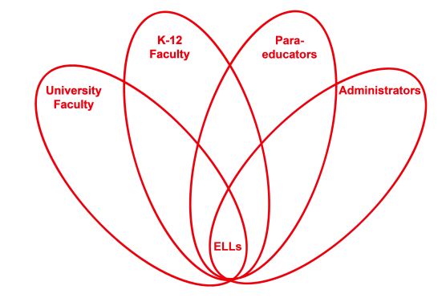

RETELL Strategy Implementation in the Classroom

Teacher | Anne Blanchette
Content Area /  Grade Level | Grade 1 Writing
Unit  (Topic or Skill) | Prewriting activity
Content Objectives | 1.W.3 SWBAT: Write narratives in which students recount two or more appropriately sequenced events. Include some details regarding what happened. Use temporal words to signal event order, and provide some sense of closure.
Language Objectives | SWBAT: Name, discuss, and tell partners tiered thematic words related to teeth brushing. Record the word on a roundtable template. Draw a quick picture to represent the word.  Level 1: Communicate by drawing a thematic picture on the roundtable template.  Use picture dictionaries to identify pictures of everyday objects (theme related) stated orally.  Level 2: Carry out two-three step oral commands such as: 1 Sit with your group. 2 Talk about brushing your teeth. 3 Draw a picture of what you talked about.  Describe how people brush their teeth when looking at pictures.  Level 5: Orally present the group template to the class.
Strategy  (Name or Type) | Vocabulary Roundtable
Brief explanation of how the strategy was used | I began this lesson by reviewing videos and class generated word lists about teeth brushing. I made sure the word list had visuals next to each word and I encouraged the class to look at it and use it if needed during roundtable activity. I encouraged the students to discuss the words with the group and help each other. Then I assigned the students to groups of 4. I passed out 1 template (sheet of paper folded into 4ths) to each group. I counted numbered heads. The Number 1 student started and passed the paper to number 2 and so on. I used a timer and set a limit of 3 minutes for each student to write a theme related word and draw a quick picture. Finally I had the group present their template to the class. Each student had a chance to show their picture and say their word.
Reflection: How and why was the strategy effective? What might you change for next time? | The students were able to work in groups with the game-like fun strategy thus lowering the affective filter. The ELLs were very comfortable working in the groups and I noticed that they were very talkative. They were able to name and write the content words and draw pictures to go with them. They practiced saying and using tiered, content, vocabulary words. They were also able to listen to their group members talk about their words. I am confident that the ELLs were able to comprehend the thematic vocabulary which will help them achieve the content objective of writing narratives.  The next time I teach this lesson I would find a poem about teeth brushing and teach the class to recite it. I would also read a book about teeth brushing and have the students work with partners to discuss the process.

If you created any handouts, presentations, or other materials to implement the strategy in the classroom and to support English language learners, please include those as well so we can share them with other teachers.

Please send this form and any additional materials as attachments to emilymrobichaud@gmail.com

