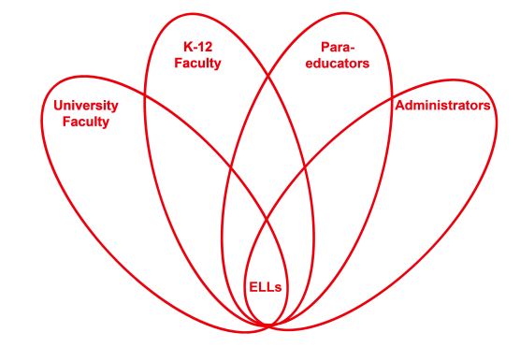

RETELL Strategy Implementation in the Classroom

Teacher | Heather Mitchell-Davis
Content Area /  Grade Level | Writing Grade One
Unit | Weather Unit
Content Objectives | I.W1.5: I can stick to a topic  RL.8.5. – For informational/expository texts: Retell important facts from a text heard or read.
Language Objectives | - Students will discuss the important facts from non-fiction text.  - Students will work with a partner and discuss sentence frames.  - Students will work with sentence frames and write to complete the frame.  Language Objective Differentiation for Proficiency Levels  Speaking  - repeated simple words  - Respond to visuals in extension activity  - TPR when discussing facts from the non-fiction text  Writing  - Copied the written language  - Make a list of facts from the book  - Communicated through drawings and graphic organizers  - Labeled their illustration using a picture dictionary and word bank
Strategy | Sentence Frames/ paragraph frame
Brief explanation of how the strategy was used | First we listened to the book How’s the Weather by Melvin  Berger. Next, we discussed Fiction vs. Nonfiction text structure and purposes. Then we went back through the book and made a chart of facts that we learned in the book.  I then put these frames on the board:  1. The weather is…  2. The temperature is …  3. I see…  4. I want to…  I then had them answer these frames and use a winter word  wall. Next, I provided them with a paragraph that had key words missing and a word bank.
Reflection: How and why was the strategy effective? What might you change for next time? | The content was more comprehensible because it gave an opportunity to discuss a very import concept. The students were able to relate to the concept. Many of my level one ELLs are new to the country and this is their first cold weather experience. They were eager to discuss what is happening outside. They feel safer working with a partner. My level ones and level twos did very well with the word bank at the end of the lesson. My students were able to come up with simple sentences and make a connection between the weather outside and the nonfiction text. They also spoke more with a partner. The paragraph activity strategy was great because they were successful in going back into the word bank to fill it in. When we were finished we all stood up and read the paragraph together. In the future I will have my students make a picture dictionary of weather words. I would have them repeat the names of key weather terms.

