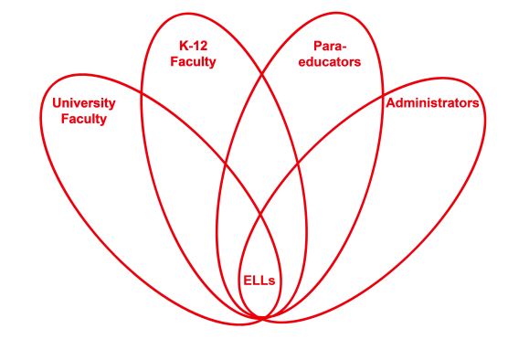

RETELL Strategy Implementation in the Classroom

Teacher | Heather Mitchell-Davis
Content Area /  Grade Level | Writing grade One
Unit | Writing/Responding to Literature
Content Objectives | I.W1.5  I can stick to a topic  RL.1.3 Describe character, setting, and major events in a story, using key details.
Language Objectives | - Students will discuss the characteristics of the characters in the story including their clothing articles.  - Students will stick to the topic and write about clothing they need for winter.  Language Objective Differentiation for Proficiency Levels  Speaking  - repeat simple words  - respond to visuals in extension activity  - TPR when discussing clothing that Froggy was wearing and clothing they need for winter.  Writing  - Copy the written language  - Make a list of winter clothing  - Communicate through drawings and graphic organizers  - Label a child and draw the clothing
Strategy | R.A.F.T. (Role-Audience-Format-Topic)
Brief explanation of how the strategy was used | The strategy was used to tell about character details. The story is Froggy Gets Dressed. At the beginning of my lesson I introduce our objectives and put them on the board. What is the author’s purpose? Then I begin to read. As I read I stop when we come to different clothing articles. We create a list of clothing that Froggy could wear in the winter. We then took the list and discussed what role we could be for writing. We decided that we would be children writing a letter to Santa asking him for warm clothes on a cold day. Our audience would be Santa and our format would be a letter. I then went through the list of clothing again. For my level one ELLs, I wrote a letter and had them copy it. I then had someone translate it. Next I had my ones write sentence frames using I have… They then added the clothing articles they had.
Reflection: How and why was the strategy effective? What might you change for next time? | The content was more comprehensible because it gave an opportunity to discuss a very important concept. The students were able to relate to the concept. Many of my ones are new to the country and this is their first cold weather experience. They were eager to discuss clothing. My students were able to come up with simple sentences and make a connection between themselves and Froggy. They also loved writing to Santa. To increase my ELLs’ engagement and interaction, the next time I try this strategy, I would have my students label a snowman with clothing. I would have them repeat the names of the clothing using complete sentences. The more we practice using the RAFT strategy the better we will be at it.

