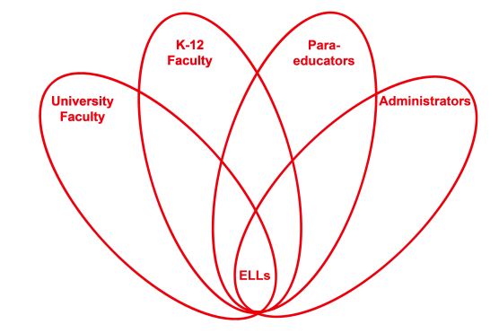

RETELL Strategy Implementation in the Classroom

Teacher | Anne Blanchette
Content Area /  Grade Level | Grade 1 Writing
Unit  (Topic or Skill) | Writing responses to text
Content Objectives | W.1.5 SWBAT: With guidance and support from adults, focus on a topic, respond to questions and suggestions from peers and add details to strengthen writing as needed.
Language Objectives | SWBAT: Discuss, pronounce and repeat words and sentences used in the paragraph frame. Create sentences using sentences frames and word lists. Write and read sentences aloud.  Level 1: Repeat simple words, phrases and memorized chunks of language from the snowmen paragraph.  Copy sentences and find words from word bank to complete the paragraph frame.  Level 2: Describe actions of snowmen from pictures in the book.  Complete modeled sentences from the paragraph frame.  Level 3: Retell part of the Snowmen story while looking at the illustrations in the book.  Level 5: Give ideas and examples of things kids can do when they play in the snow.
Strategy  (Name or Type) | Paragraph Frame
Brief explanation of how the strategy was used | I began this lesson by rereading the book Snowmen At Night by Caralyn Buehner and introducing the word bank with visuals. Next I posted the paragraph frame and read it orally. During the reading the class worked orally with partners to figure out the words that fit in the frame and made sense in the sentences. Then the students copied the paragraph and filled in the words using the posted word bank. I worked with the ELLs in a small group. I Used the book to incorporate language objectives to help with the comprehension and completion of the paragraph frame. Finally the students practiced reading the paragraph.
Reflection: How and why was the strategy effective? What might you change for next time? | The students had numerous opportunities to pronounce, repeat and discuss the words and sentences in the paragraph frame. All of the students were able to find the correct words, pronounce them and fill in the blanks when I read the sentences. As a result of the oral practice and repetition, all ELLs were able to read the paragraph with minimal teacher support.  Next time I teach this lesson I would incorporate science content. I would bring snow into the classroom and make a mini snowman with tiny objects for the face and arms similar to the snowman in the story and let the students watch the snowman melt and teach the concept of melting. I would also encourage the students to discuss how real snowmen compare to the actions of the snowmen in the story.

If you created any handouts, presentations, or other materials to implement the strategy in the classroom and to support English language learners, please include those as well so we can share them with other teachers.

Please send this form and any additional materials as attachments to emilymrobichaud@gmail.com

