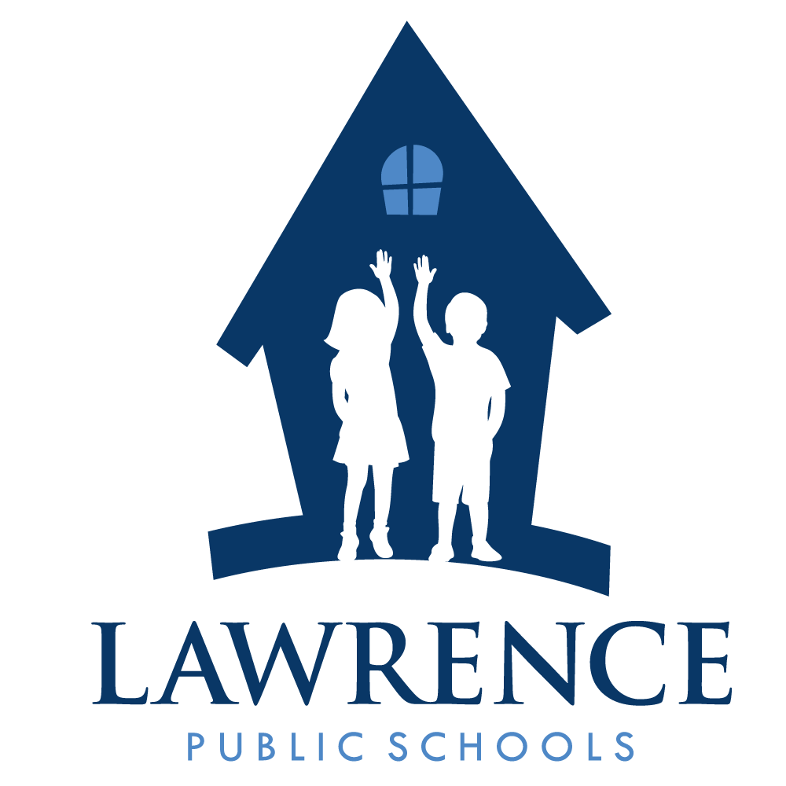
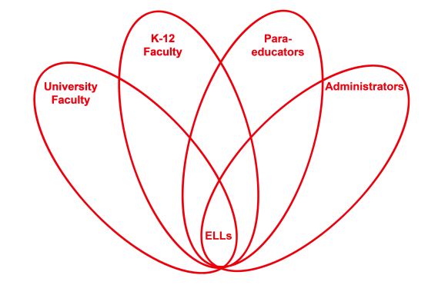

RETELL Strategy Implementation in the Classroom

Teacher | Heather Mitchell-Davis
Content Area /  Grade Level | Reading Grade One
Unit | Responding to Literature: Thanksgiving
Content Objectives | CCSS.ELA-Literacy.W.1.1 Write opinion pieces in which they introduce the topic or name the book they are writing about, state an opinion, supply a reason for the opinion, and provide some sense of closure.
Language Objectives | - Discuss with partner the difference between pilgrim habitats and Native American habitats.  - Write complete sentences identifying where the Native Americans lived and where the Pilgrims lived.  Language Objective Differentiation for Proficiency Levels:  - Level One students will repeat simple words and phrases and memorize chunks of language  - Respond to visually supported questions of academic content with one word or phrase  - Identify the houses  - Participate in whole group chants and songs  - Copy written language  - Use L1 medium of instruction to help form words in English  - Communicate through drawings  - Label familiar objects or pictures
Strategy | Word Wheel
Brief explanation of how the strategy was used | Students will listen to and read Scholastic Thanksgiving  Edition: Wampanoag and Pilgrims. Students are writing about Thanksgiving. We are reading a nonfiction magazine and then going to create a book writing in complete sentences. The word wheel will be used to  help expand the true definition and explanation of what a teepee is.
Reflection: How and why was the strategy effective? What might you change for next time? | This strategy helped students to understand what a teepee was when they started to figure out that it was a shelter. It became clearer for them after we constructed a teepee and then made our own to put on our desk. This is similar to acting out but with a noun. My students were then able to use the word “compare” and discuss different habitats. Next time, I will have more pictures available of different habitats.

