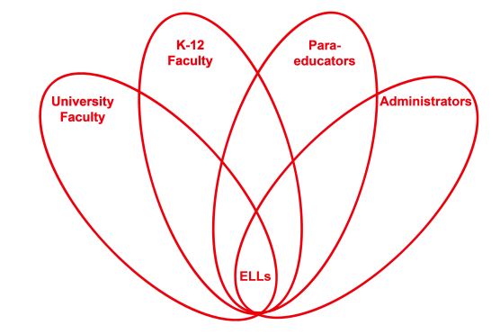

RETELL Strategy Implementation in the Classroom

Teacher | Anne Blanchette
Content Area /  Grade Level | Grade 1 Reading
Unit  (Topic or Skill) | Practice reading and discussing grade level texts.
Content Objectives | 1.RI.1 SWBAT: Ask and answer questions about key details in a text.
Language Objectives | SWBAT: Listen to partners read.  Ask, answer and discuss questions and answers about the texts.  Level 1: Point to objects in partners texts, reflective of oral statements.  Level 2: Describe what people do from action pictures in texts.  Locate objects in pictures in texts and describe orally.  Level 4: Find details in illustrations when partner reads aloud.  Level 5: Express and support ideas from texts with examples.
Strategy  (Name or Type) | Partner Reading
Brief explanation of how the strategy was used | First I read the story Little Bear’s Visit by Else Holmelund Minarik. During the reading I stopped and modeled comprehension questions. I also had the students turn and talk to ask and answer questions with their partners. Finally I sent the students off with their partners. They read books from their independent reading bags. I circulated and listened to the reading and helped and encouraged students to ask and answer questions. I also used the leveled language objectives with the ELLs. Some of the fluent English speaking students observed me using the leveled language skills and began doing the same thing with their ELL partners. I loved this and praised and encouraged them to continue to help their friends learn English.
Reflection: How and why was the strategy effective? What might you change for next time? | This strategy helped my Ells’ engagement and interaction. All of the students in my class love partner reading. I partner students according to reading ability and language proficiency. This placement promotes English language production and academic language discourse.  The next time I use this strategy I will use nonfiction literature. I will take a class trip to the library and give the students an opportunity to choose thematic books to keep in school and read during partner reading.

If you created any handouts, presentations, or other materials to implement the strategy in the classroom and to support English language learners, please include those as well so we can share them with other teachers.

Please send this form and any additional materials as attachments to emilymrobichaud@gmail.com

