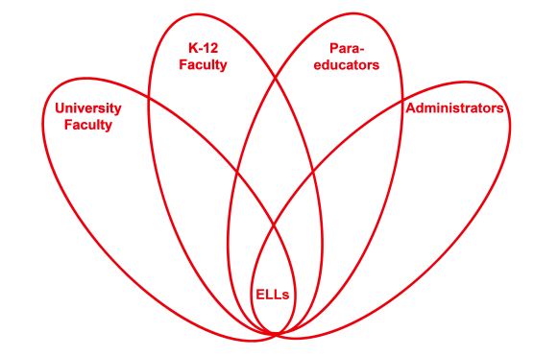

RETELL Strategy Implementation in the Classroom

Teacher | Anne Blanchette
Content Area /  Grade Level | Grade 1 Reading
Unit  (Topic or Skill) | Reading poetry
Content Objectives | 1.RL.10 SWBAT: With prompting and support, read prose and poetry of appropriate complexity for grade 1.
Language Objectives | SWBAT: Read a poem aloud, pronounce and repeat words from a lexical array list and produce language using a sentence frame.  Level 1: Participate in a whole group chant while reciting the poem Albuquerque Turkey by B .G. Ford.  Repeat words from the lexical array and memorized phrases from the poem.  Level 2: Use pictures from book pgs. 5, 6, 7, and 10 to describe how and where the turkey follows the farmer.  Level 3: Use the pictures in the book to retell the story.  Level 5: Choose a word from the lexical array and explain the word and give an example of the word in a sentence.
Strategy  (Name or Type) | Lexical Array: Word: follows Synonyms: chases, pursues, tracks, runs after
Brief explanation of how the strategy was used | I began the lesson by reviewing the familiar poem (book and illustrated poetry chart) Albuquerque Turkey by B .G. Ford. I displayed pictures of the turkey following the farmer on page 5, 6, and 7. Then I wrote the word follows and discussed the meaning. I then wrote the synonyms. I used each word in a sentence. The students discussed them with partners and as a class we made a list of the words in order of difficulty. I posted a sentence with the word follows from the poem. The class read the sentence together. I covered the word follows. Finally the students took turns reading the sentence and choosing a synonym from the lexical array list to fill in the blank.
Reflection: How and why was the strategy effective? What might you change for next time? | This strategy was successful because the ELLs were familiar with the poem. They enjoyed reciting it and had good comprehension of the word follows. Each time a student used a different synonym, the whole class repeated the sentence. The ELLs were familiar with the language because of the repetition. They were able to listen to fluent English speakers and they had the chance to practice the language. They were confident and excited when they read the sentence. All of the ELLs were able to fill in the blank and read the sentence with minimal teacher support.  The next time I teach this lesson I would let the students hold paper bag turkeys that they had previously made in class and use them like puppets to act out the story while reciting the poem. I would also have the children act out the words on the lexical array by modifying the game “Duck- Duck-Goose”. The students would sit in a circle and hold their turkeys. One student would be chosen to be the farmer. The farmer would choose a turkey. Lastly the turkey would use one of the synonyms in a sentence and act it out while trying to tag the farmer.

If you created any handouts, presentations, or other materials to implement the strategy in the classroom and to support English language learners, please include those as well so we can share them with other teachers.

Please send this form and any additional materials as attachments to emilymrobichaud@gmail.com

