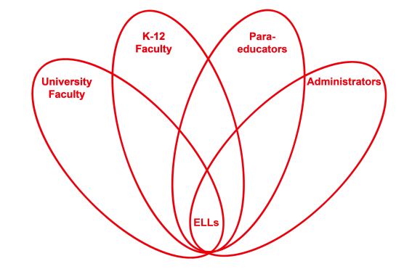

RETELL Strategy Implementation in the Classroom

Teacher | Heather Mitchell-Davis
Content Area /  Grade Level | Reading (Grade 1)
Unit | Responding to Literature
Content Objectives | RL.1.3 Describe character, setting, and major events in a  story, using key details. My questions are: What is the  purpose of the author writing this book? What does the  author want us to know?
Language Objectives | Students will discuss the characteristics of the characters in the story.  Language Objective Differentiation for Proficiency Levels  Speaking  - repeat simple words  - respond to the visuals when making the web  - TPR when acting out the character traits  Writing  - copy the written language  - communicate through drawings and graphic organizer  - label the web
Strategy | I wonder…
Brief explanation of how the strategy was used | - The story is Leo Lionni’s It’s Mine.  - As I begin my lesson I introduce our objective and put it on the board: What is the author’s purpose?  - Then I begin to read. The first word I come to is on page 4. The word is quarrelsome.  - I then put “I wonder” on the board. I wonder what the word quarrelsome means?  - We then create a web with quarrelsome in the middle.  - I then had the students repeat the phrase “I wonder what quarrelsome means.”  - Next, the students turned and spoke to a partner.  - They then came up with a list for the web: mean, arguing, fight, disrespectful, bickering, yelled, rude, angry and inappropriate.  - I then went through the list and acted out the words so that my level ones and two might have more clarification.
Reflection: How and why was the strategy effective? What might you change for next time? | The content was more comprehensible because it gave an opportunity to discuss a very import concept. The word quarrelsome was really the gist of the author’s meaning. When we were finished with the web, the students discussed how the frogs continued to say, “It’s mine,” and how that can lead to an argument. My students were able to come up with simple sentences and make a connection between the frogs (characters) and when a classmate does not share. Next time, I will have my students draw an illustration about a time they had a quarrel. I then think it would help for them to act it out.

