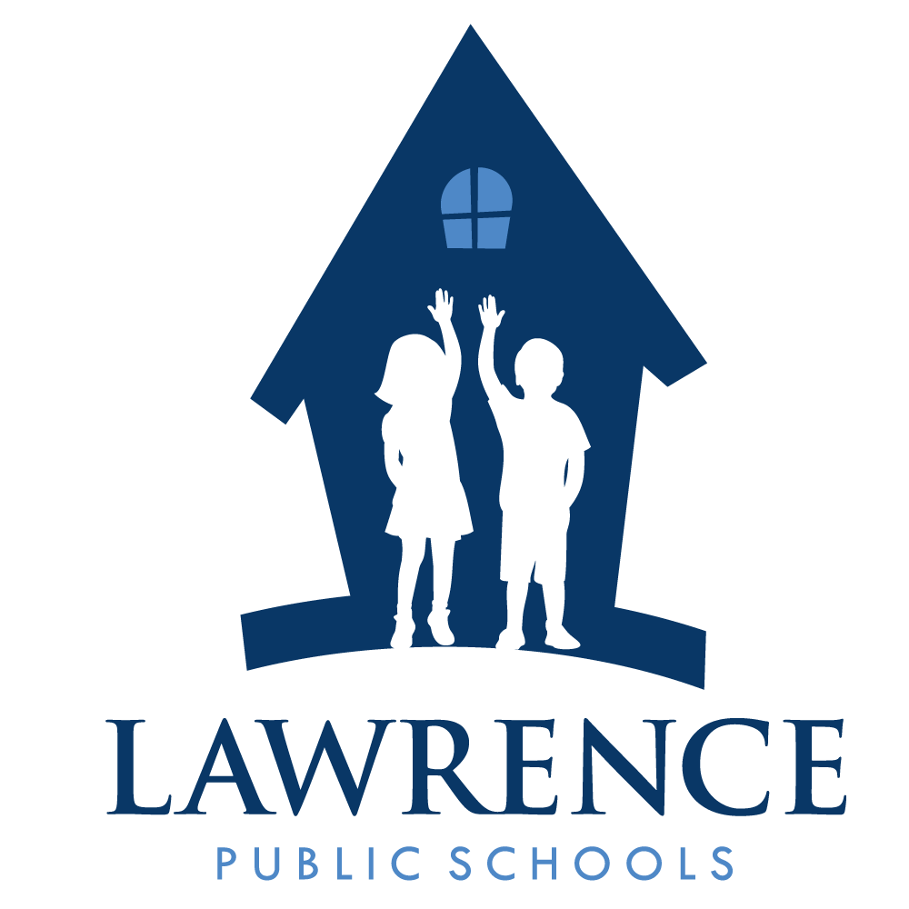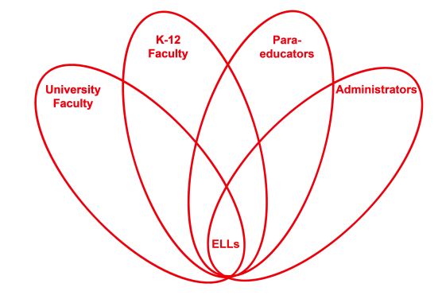

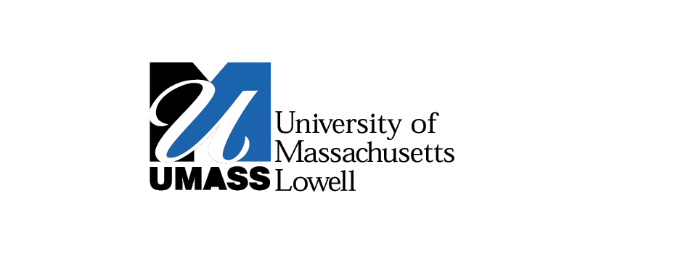

**RETELL Strategy Implementation in the Classroom**

|  |  |
| --- | --- |
| **Teacher** | Heather Mitchell-Davis |
| **Content Area /**  **Grade Level** | Grade one reading |
| **Unit**  **(Topic or Skill)** | Balance Literacy |
| **Content Objectives** | CCSS.ELA-Literacy.RF.1.2 Demonstrate understanding of spoken words, syllables, and sounds (phonemes).  CCSS.ELA-Literacy.RF.1.2a Distinguish long from short vowel sounds in spoken single-syllable words.  CCSS.ELA-Literacy.RF.1.2b Orally produce single-syllable words by blending sounds (phonemes), including consonant blends.  CCSS.ELA-Literacy.RF.1.2c Isolate and pronounce initial, medial vowel, and final sounds (phonemes) in spoken single-syllable words.  CCSS.ELA-Literacy.RF.1.2d Segment spoken single-syllable words into their complete sequence of individual sounds (phonemes). |
| **Language Objectives** | * Pronounce sounds of letters in order to blend and read words aloud.   Language Objective Differentiation for Proficiency Levels:   * SWBAT: State and repeat sentences using sentence frames with the targeted vocabulary word. (Instructional paraprofessional will work with a small group of students coded level 1.) |
| **Strategy** | 7 step strategy for vocabulary |
| **Brief explanation of how the strategy was used** | * Described : “Chunky Monkey” Strategy (chunk the word): Look for a chunk, look for a word part. * Show book *A Play for All* by Meisha Goldish * Read title and take a picture walk * Use 7 step vocabulary strategy to explicitly teach the word “responsibility.” * Read the story and stop on page 2-3 to discuss vocab word and show picture of students demonstrating responsibility. * Stop during the story to use modeling and think alouds to demonstrate the “Chunky Monkey” look for word parts strategy. * After the story ask comprehension questions (that involve responsibility) so students will have more time to practice the vocabulary words. |
| **Reflection: How and why was the strategy effective? What might you change for next time?** | Students understood the pre taught word when we acted it out and looked at the picture in the book. It also became clearer for them when they heard it in the context of the story. My students were able to use the vocabulary word after the story when sharing with their partner and answering comprehension questions about the story. A question example is: How did the students demonstrate responsibility in the story? The next step will be to act out the word by placing two students in the front of the room. I will then give them a baby doll and tell them it is their responsibility to care for it. I will then ask them to demonstrate the word “responsibility.” I will encourage students to think-pair-share and use the word “responsibility” with their partner. |